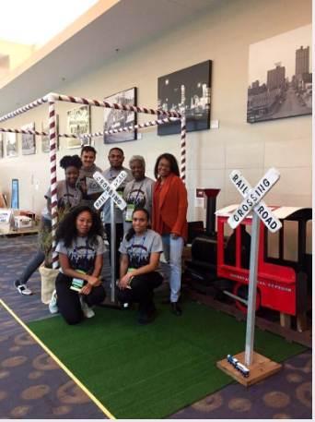
The Polar Express Comes to Waco celebrates the history of mobility and transportation in Waco, by using the concept of a train as a “vehicle” that not only moves people around but also moves through cultures and time. The structure is intended to resemble the boxcar of a train while also creating a boundary between the street and parklet space. With features such as a small grass area, the structure being secured by portable gardens that can hold ornamental plants or edible herbs, and the high-visibility of the structure regardless of time of day, The Polar Express Comes to Waco pays homage to the history of the city while simultaneously nodding to it’s progressiveness. In light of various comprehensive plans, creating green spaces in Downtown was imperative and we believe our structure speaks to the immediacy of this need due to it’s highly affordable construction and adaptable footprint. While we’re considering the history of transportation today, the concept can easily be transitioned into a farmer’s market booth, extension of restaurants that spill out into the streets, a unique space to enjoy a book, and more.

