Andret Rayford, Program Director
STAJS Consultant, “THE PLACE”
Education Planning Consultant
Subject: RFP-Settegast, Houston TX 77028
The Complete Communities Initiative was established to collaborate, impact, transform and improve communities of color. Complete Communities’ definition is a working project with mechanisms to identify the qualities that lead to a thriving neighborhood’s future. The initiative is designed to advocate and strengthen many low-income, small neighborhoods for better quality of life. As of 2017, Mayor Sylvester Turner initiated Complete Communities as a pilot program in 5 locations: Third Ward, Acres Home, Gulfton, near Northside and Second Ward with different need assessments and challenges. Each community was assigned a City Planner to research, plan, support and develop a vision with stakeholders for specific knowledge and engagement.
The five communities shared their insights, values and visions by attending fourteen public meetings with faith-based organizations, business owners, neighborhood civic leader, schools and residents to identify priorities to ensure the community can revitalize and rebuild. The communities serve as a sounding board for the effort to provide connection to residents and businesses for healthy, prosperity and equity for the greater good. After a year of collaboration and engagement with the five communities an Action Plan was outlined with visions, goals, objectives and projects for resilience, sustainability and socioeconomic growth. The city has extended the program to five other neighborhoods; Alief, Fort Bend, Houston, Kashmere Gardens, Magnolia-Manchester and Sunnyside. Another distressed neighborhood, a customer of STAJS Consultant, is Settegast, Houston 77028.
STAJS Consultant was created to provide support to a community not involved in Complete Communities Initiative as the ten communities listed above. The city has new community developed neighborhood sub-divisions growing and aging communities are in distress. I have my graduate degree in Education Administration and Urban Planning Environmental Policy (UPEP) from Texas Southern University (TxSU). The UPEP education has given me the experience to support and conduct community engagement with stakeholders in low-income, underserved neighborhoods. My experience with American Planning Association (APA) Planning Student Organization (PSO) legacy project gave the TxSU Student Planning Organization {SPO} opportunity to create a design for Hitchcock Town Center corridor. We won and was interviewed in the Galveston Daily with our plan to design and promote the small city’s development. We were asked to promote our city plan to Hutson-Tillotson HBCU Social Justice Summit and prophesized as consultants.
My first community project was introduced at TxSU Houston Community Land Trust conference on June 13, 2019. Dr. Rosalyn Francis grew up in the area and decided to return as the Director of Settegast Heights Redevelopment Corporation (SHRC), we met and discussed her problems in the community. She invited me to an investment meeting to discuss what role I would play, being an urban planner specialist would help her develop plans of the 8 urban planning principles “THE PLACE”; transportation, health wellness, history preservation, housing affordability, educational training, entrepreneurship, economics and environmental sustainability in public land-use and community engagement. STAJS (stages) Consultant is the format of Complete Communities Initiative but more personalized to the community as a customer assessment. This will create the specific model to fit that community with a SWOT analysis and need assessments for all stakeholders. STAJS Consultant and SHRC started coordinating and collaborating since June 26. 2019.
The study area map in northeast Houston, 610 and North Wayside to Ley Road, east/west, South Pacific Rail Road to East Houston Road.
Settegast 77028 CT 2309 Block 3 Demographics https://www.houstontx.gov/planning/Demographics/docs_pdfs/SN/50_Settegast.pdf
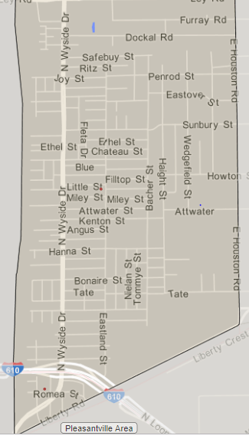
Population-4,270 Female 2,306 (52%) Male 1,964 (48%)
Demographics: Blacks 3,154 (70%)
Hispanics 1,075 (27%)
Whites 41(3%)
- Median income-$25,286
- Median age-40
- Families with children-21%
- Single mothers-22%
- Median houses built-1963
- Occupied housing units-1,501(74%) Vacant (26%)
Properties long-term tax liens 25%
Schools: Bennie Carl Elmore Elementary-Mrs. Fugit (only school located in the area)
Forest Brook Middle-Mrs. Gentry
North Forest High-Mrs. Smith
Children below the poverty level 61%
High school diploma 1,757 (60%) No high school diploma 969 (33%)
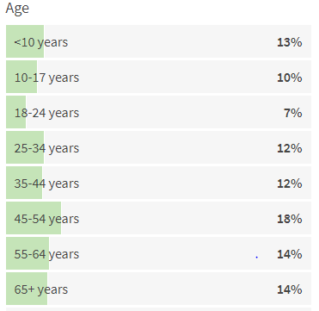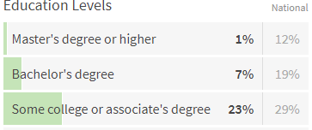
Settegast Houston, TX 77028 profile, http://www.city-data.com/neighborhood/Settegast-Houston-TX.html
The community is 127 years old and all the 6 urban planning principles “THE PLACE” are affected. The collaboration began with these events. A meeting with B C Elmore, Principal Faith Fugit collaborated with the school’s open house and SHRC health fair on September 26. The event was a success and data were collected. STAJS Consultant and SHRC named the community “Community of Churches” which are all over 20 + years with 35+ churches. A Pastoral Council of 8 ministers on September 13. discussed the distressed issues in the community and applying for the National Historical Preservation funds to create 3 landmarks for 2020. On August 7 we met with Lone Star Legal Aid (LSLA) to discuss legal assistance and got approval on August 27 as a group client. On September 26, LSLA met with SHRC and the Pastoral Council to discuss community issues and tour Settegast for legal assistance. SHRC coordinated with Hometown Senior Living facilities with a Line Dance and Bar-b-que event on September 27. The event was a success and data were collected.
SHRC meeting to create a small neighborhood action plan (SNAP) for 2020-2022 forecast with the 8 urban planning principles. Future meeting engagements with the business owners and HISD elementary, middle, high school principals and the Wraparound Specialist on need assessment for the school’s feeder pattern program. The need for connection with HCC North Forest NE campus, President Dr. Monique Umphrey for new student enrollment.
One trend in planning is assisting and advocating for small low-income underserved communities for the greater good. STAJS Consultant passion is to serve small communities of color needing solutions for socioeconomic growth, housing affordability, entrepreneurship, youthification, beautification and faith-based organization collaboration with community engagement for better quality of life.
I am asking for $65.000 with a 2-year contract as an Independent Contractor to continue the community partnership with a personal connection with Dr. Francis, SHRC Community Director and the stakeholders to revitalize and rebuild an aging community. The funds will offset field work, operational cost, technology tools, marketing tools, community engagement, meetings and consulting fee.

You may reach me at 832-453-8586 or email me at andret.rayford@att.net at your convenience.
Thank you.

Andret Rayford, Founder and Program Director
STAJS Consultant, “THE PLACE”

