Retrofit Educational Basic Skills:
Our Youth’s Tomorrow

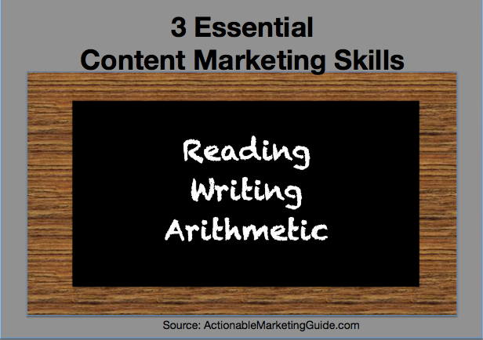

Abstract
The purpose is personalizing and tailoring our youth to their learning styles, catering their learning skills and motivating them to grow and produce authentic, unique skills for future endeavors. The problem is our Black students continue to show test scores lower than Whites in reading and math. Hispanic students are gaining and closing the gap with Whites and Blacks in reading and math. The need to retrofit old school directions for assessment on performance and achievement instead of teaching how to bubble in the answers. An educator’s toolkit to teach with creativity instead of teaching and cramming for STARR test assessment. The end results on how to balance academic basic skills with anger management, etiquette, dressing to impress, filling out applications, job interviews, expressing their qualifications and identifying their skill sets for career opportunities.
Gardner, Bloom and Maslow studies dealt with conditioning the mind on how a person understands and adapts to their environment. The studies will be used to measure a child’s adaptation to learning and help their ability to grasp information. The eight skill steps will provide better results for achievement and success for career and college readiness. A student’s personal gain, fulfillment, motivation and preparation for what life has to offer from attending Pre-K to secondary and career technical training, higher learning education or certification to career choices. The foundation of educating our students are teachable moments that needs to address their learning styles and skills. If you can assess their learning styles you can achieve their learning skills and build confidence to grow and be successful. The access to meet our students where they are and build stronger relationships for quality of life.

Retrofit Educational Basic Skills: Our Youth’s Tomorrow
Introduction
- Education demographic progression 1940-2010
- Assessing a student’s cognitive and creative learning skills
- Howard Gardner’s learning styles
- Bloom’s Taxonomy learning skills
- Maslow’s Hierarchy framework
- Education are teachable moments for student’s learning skills and styles
Why is this relevant: Gregg Abbot’s Tweet Shine Spotlight on Troubled Houston ISD
- Identifying the Academic Gap
- HISD History
- Problems and Progress
Who are we addressing: Educator Toolkit-Tailor/Cater/Motivate Student’s Learning Styles/Skills
- Tailor-to fit an individual’s needs
- Howard Gardner’s 8 Learning Styles or Combinations
- Linguistic-reading writing listening speaking/self-learner
- Naturalist-nature experiences experiment
- Musical-sing rhythm/listen auditory
- Kinesthetic-hands on physical doer creator
- Visual-seeing diagrams pictures graphs
- Logical-thinker of patterns numbers equations/list
- Interpersonal- works well with others team player extrovert/social
- Intrapersonal-stays to themselves shy introvert
- Cater-provide what is needed or required
- Benjamin Bloom 8 Skill Steps
- Remembering/memorization
- Understanding/comprehension
- Applying/doing
- Analyzing/cognitive thinking
- Evaluating/resolutions
- Creating/end results
- Growth-motivate personal gain
- Maslow’s Hierarchy of Needs
- Psychological-survival
- Safety-protection
- Belonging and love-family and friends
- Self-esteem-self and respect
- Cognitive-knowledge and understanding
- Aesthetic-beauty balance form
- Self-actualization-personal growth, fulfillment, potential
- Transcendence-mystical, aesthetic, sexual
When do we begin: 2020 Start of a New Decade
- Smithsonian Education Laboratory for Learning and Innovation
- Curriculums, Programs, Responsibility and Accountability
Conclusion/Recommendations
- Brain Trust Committee
- Bridge the GAP

Retrofit Educational Basic Skills: Our Youth’s Tomorrow
Introduction
Let us turn back time and explore education in the 40s, 50s, 60s and 70s. In the first writing, Houston Urban Education: Identifying the Academic Gap, the discovery was a closing gap for the history of academic performance in public education. The tremendous historical events, ideas and trends existing in the United States presented an academic gap toward accountability which was used to assess what happened in 1940-2010. The same is true for Texas. The National Center of Educational Statistics began with basic items in 1870 to present. The data provides high school degrees, 60 years of Texas education attainment by both sexes and demographics with a small margin of identifying the academic gap. Figure 1 identifies the closing gap between Whites, African Americans and Hispanics graduation rate from 1940-2010.
The objective is assessing a student’s cognitive and creative ways of learning by tailoring the students thought process to the Howard Gardner’s learning styles. The assessment “What is the student’s learning styles” with 20 questions will help establish three different types of learning abilities the child possesses. The information can be stored in the teacher/student’s personal file to implement and change with the subject matter. The assessment can be altered to fit the need of the student with his/her learning styles. A teacher must differentiate the students because of inclusivity in the class which would help the process of an individual’s foundation pattern. The purpose of the assessment will create the use of the Bloom’s Taxonomy steps to cater to a student’s learning skills. The eight steps Bloom introduced has classified learning outcomes and objectives that provides cognitive skills and creative tasks construction. And a student reaching the highest level will institute their foundation for achieving success in most areas of learning.
The results for attaining education are teachable moments that needs to address a student’s learning skills and styles. If you can assess their learning styles you can achieve their learning skills. Another hierarchy is the Maslow ladder on biological and psychological needs of the student. One would question if Maslow’s hierarchy should be first in assessing a student. This would not begin showing until the student has a bond with the teacher or trusting authority. The teacher can speculate but a conversation and kindness will form a relationship to know the student’s home environment. A teacher should have structure and consistency to bring into being an openness for the student’s personal conditions. When observing Mrs. Lucas class there was structure and rewards for good behavior. There was also some aggressiveness to keep the students in order. A teacher should always give praise and encouragement for a student’s success. Remember to keep expectations and motivation high and on-point by their learning styles. Keep in mind the child’s home environment and situations while reprimanding an issue. Sometimes a teacher has a lot to consider but the Gardener, Bloom and Maslow theories are assets to psycho-education spectrum.
“Cause I Ain’t Got No Pencil,” by Joshua T. Dickerson:
I woke myself up
Because we ain’t got an alarm clock
Dug in the dirty clothes basket,
Cause ain’t nobody washed my uniform
Brushed my hair and teeth in the dark,
Cause the lights ain’t on
Even got my baby sister ready,
Cause my mama wasn’t home.
Got us both to school on time,
To eat us a good breakfast.
Then when I got to class the teacher fussed
Cause I ain’t got no pencil
Gregg Abbott’s Tweet Shine Spotlight on Troubled HISD
The expectation for change in HISD is being criticized by Gregg Abbott, Republican Texas Governor, “HISD leadership is a disaster. Their self-centered ineptitude has failed the children they are supposed to educate. If ever there was a school board that needs to be taken over and reformed, it’s HISD. Their students and parents deserve change.” In 2015, Texas passed a strict law that allowed the state to impose sanctions on school districts with schools that consistently failed to meet state academic standards. Houston ISD must boost the performance of four of its chronically low-performing schools in 2019, or it will be taken over by the state or be forced to shut down those schools. The agency’s narrative of failing schools is based on testing and promoting privatization policies as the solution. State government is holding a gun to the head of the public and demanding we surrender our students.
HISD could end up becoming the poster child for the law’s sanctions and strict timeline. It’s the biggest district in Texas, with more than 200,000 students and a $2 billion budget. Plus, it has the most schools, more than a dozen, that have missed the state’s standards for three or more years. In Texas education, their labeled “improvement required.” This law, known as House Bill 1842 in 2015, allows the commissioner to appoint outside managers, if a district has even one campus that chronically fails. the state’s standards for five or more years. The district’s elected officials could face the consequences and lose their jobs. The latest report of the 5 out of 13 schools failing are: Henry Elementary, Highland Heights Elementary, Kashmere HS, Wheatley HS and B.T. Washington HS not rated because of Harvey provision. This link has all campus ratings (1,561 entries), https://www.houstonchronicle.com/news/education/article/TEA-to-release-STAAR-test-results-accountability-13155977.php.
Identifying the Academic Gap

To present the most consistent data, Whites and African Americans are the only demographics reported from 1940 to 1980. Education data did not begin for Hispanics until 1980 with moderate progression of closing the gap and receiving high school diplomas. The African American males and females showed a distinct closeness to White males and females, as shown in Table 1.

Table 1:
Texas | HS1940 | 1950 | 1960 | 1970 | 1980 | 1990 | 2000 | 2010
Whites | 27.3 | 33.3 | 42.0 | 49.5 | 65.7 | 76.2 | 79.5 | 93
Blacks | 8.4 | 12.0 | 20.8 | 30.1 | 53.0 | 66.1 | 75.8 | 84
Hispanics | N/A | N/A | N/A | N/A | 35.5 | 44.6 | 49.3 | 84
Source: A Half Century of Learning: Historical Census Statistics on Education Attainment: 1940-2000 Tables 7, 11 and 13, November 29, 2016. Source: National Center for Education Statistics, Common Core of Data State Dropout and Graduation Rate Data 2010 (HS=high school graduates)

Figure 3: (below) displays White females and males with African American females and male’s progression in education from 1940 to 1990. In 1960, a rise of African American median years of school completion by males rose 10.5 to 12.2. The middle of 1970 to 1990 remained stable but slowly closing for minority young adult’s educational attainment.

During the 1940s and 1950s young cohorts believed in completing higher education to make a mark on the adult population. Many of these young adults completed high school and median educational attainment rose to 12.3% consecutively. By 1960, 42% of males had only completed the eighth grade, 40% completed high school and 10% complete a 4-year institution. The proportion of women remained the same as men but lower for 4-year schooling. In 1991, 70% of African American males completed high school and 69% females did the same. This is lower than White males and females of 80%; however, the differences narrowed in the coming years (National Center for Education Statistics 1993).
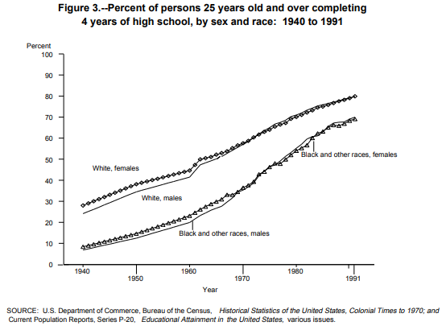
Houston ISD History

Houston ISD is the largest district in Texas with 284 schools, 8 early childhood campuses, 159 elementary, 38 middle, 38 secondary, 41 combined primary or secondary and 12 charter schools. The enrollment of students to date 214,175, Whites 8.70%, African Americans 24.02%, 61.84% Hispanics and 74.93% economically disadvantaged. Houston ISD is the 4th largest traditional public school (TPS) district in Texas has a disparity with student achievement among Whites, Blacks and Hispanics. The current trends in HISD academic gap reflects different factors over the past 20 years of the district’s history. The increase of Hispanic students has grown expediently since 1975. Why are there so many HISD low-poverty campuses showing Improvement Required (IR) over the 3 to 5-year span? The facts and figures of the district identify the increase of Hispanics attending HISD and the development to assess the growth for achievement by data analysis on curriculum assessment during 1995-2015 school years. HISD beliefs in a wraparound service plan to connect with the whole child’s social and emotional support. The focus on STARR testing goals set by state, district and campuses to accommodate student’s achievement for K-12 grade level promotion and higher graduation rates.

HISD had a large group of white students until 1972-73 when black students increased enrollment after the period of “white flight” from major urban districts across the US. Historians suggested white flight occurred when Blacks migrated from the South to northern cities in the Great Migration waves of immigrants from eastern and southern Europe. In 1975, the student body was 39 percent Whites and 19 percent Hispanics. In 1981 there were 190,00 students enrolled in HISD with 31 percent Hispanics and 21 percent Whites. The Hispanic demographics increased in 1989-90 and became the largest HISD demographic group in the district. In 1990 the student population became 43 percent Hispanics, 40 percent Blacks and 15 percent Whites, 45 percent of the district has no White students. HISD reported in 1990 an increase growth into racial and minority student groups.

In 1968-69 the total enrollment of White students was 131,032 which decreased every year to 20,062 in 2001-02. The Hispanic student’s enrollment in 1968-69 was 30,724 and increased every year reaching 118,200 in 2001-02. The Black students fluctuated throughout 1968-69 with 81,729, an increase of 91,157 in 1977-78 and then to their lowest of 65,951 in 2001-02. As of 2001-02 Hispanic students were the largest group in the district with 56 percent. The Black students represented 31 percent and White students represented 10 percent with others less than 5 percent of student enrollment. The number of economically disadvantaged students increased to 100,445 in 1990-91 to 166,429 in 2001-02 with a 66 percent increase in twelve years. In 2001-02, 79 percent of the total enrollment was economically disadvantaged.

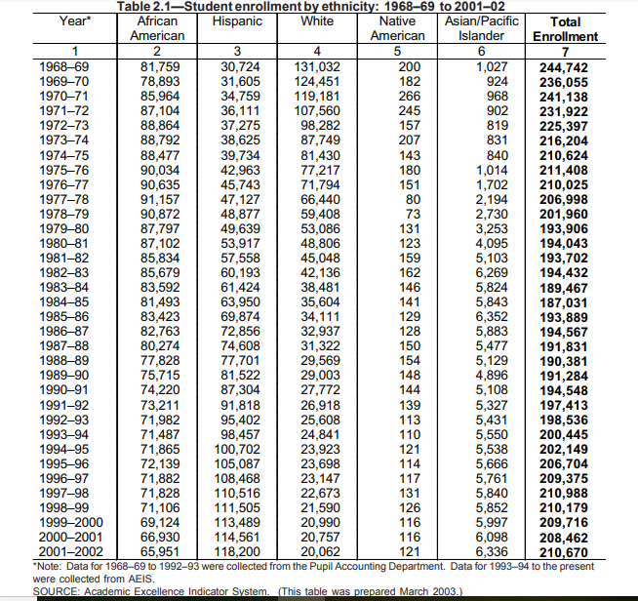

HISD student’s ethnicity data 2015-16 reports African Americans, 24.5 percent (52,735), Hispanics, 62.1 percent (133,889), Whites, 8.5 percent (18,217) and others less than 5 percent. The economically disadvantaged enrollment 76.4 percent with 164,648 student enrollments. Students by grade levels make up total enrollment of 215,627 with 15.4 percent Pre-K/Kindergarten, 41.6 percent Elementary, 18.9 percent Middle and 24.9 Secondary schoolers. The data for 2015-16 shows HISD facilitates 10 early childhood centers with 5,630 student’s enrollment, 158 elementary campuses with 105,727 students, 37 middle campuses with 3,3232 students, 46 secondary campuses with 46,104 students, 42 middle/high, alternative and charter campuses with 23,934 students.

3/18/2019 HISD Problems and Progress

HISD has had several superintendents in the past 30 years. Rod Paige, February 1994-February 2001, Kaye Stripling, February 2001-August 2004, Abelardo Saaverdra, August 2004-August 2009, Terry Grier, August 2009-May 2015, Richard Carranza, August 2015-March 2018 and Grenita Lathan, Interim August 2018 to present (Houston Chronicle, March 2018). The interim Superintendent Grenita Lathan commits to transforming these 10 failing campuses from IR to MS for 2017-18 test scores improvement. The ten campuses are called “Superintendent Schools” because of their failing scores over the past 3-7 years. Superintendent. Lathan, before her present position in March 2018, served as Chief School Officer over elementary transformation schools 2015-16 year. She accomplished the turnaround of 20 schools out of IR to MS ratings and promoted to Chief Academic Officer 2016-17. The program has increased support from the district leadership and centralized assistance from various departments. The focus on collaborating and addressing the causes of the underperformance of the schools with a “school improvement plan. The school board approved and submitted to TEA the decisions to implement Achieve 180 program (HISD.org).

The plan made various changes to 42 campuses and two in-district charters with lay-offs, new principals at failing campuses, rotation of principals, pay incentives to attract and retain highly-effective teachers and instructional staff with additional services for student’s social and emotional attention. Some tweaks with staff development hours, full-time nurse on site, dedication to connecting students with social services and more events for parent engagement. Demonstrate A180 partners similar demographic campuses with consistent MS ratings over several years or campuses with gains from IR to MS consecutively over two years with IR campuses consecutive failing over the 3-7 years. My daughter is a 1st grade teacher at Frost Elementary informed me that her Principal, David Terrell (School Leadership Academy leader) partnered with Mading Elementary to assist with improving their failing status. Collaborate A180 has partnered teachers with distance learning teachers to plan lessons, plan delivery of instruction and feedback on instructional programs. Principals are partnered with other principals to assess their effectiveness with campus professional-learning and design a plan to improve outcomes (HISD.org). The program shows some increase and HISD leaders want a 3-year plan proposed budget to continue the process. Achieve 180 can get cut if four of the chronically failing campuses does not meet all state academic standards this year. Under HB 1824 law passed in 2015, allows sanction for chronically failing schools closure and state takeover, TEA can replace the school board and/or close the failing campuses. TEA has not commented about the sanction, but some public comments have been circulating about changing the school board members. If so, the new trustees and superintendent can decide to abort some or all the Achieve 180 program implementations.

The data analysis breakdown with elementary, middle and high school passing and failing 2015-16 school year is alarming. Black students have low scores in many of the campus reports which shows below 50 % in different areas. There is congratulation due for schools with outstanding rankings and ratings for 30 years, 21 elementary, 1 middle, 2 high school and 2 charter programs. HISD have 10 schools ranked top performing on C@R 2017 list. The top 10 HISD schools are TH Roger-1, Horn-4, River Oaks-5, West University-6, Mandarin-9, Project Chrysalis Middle-4, Lanier Middle-6, DeBakey Health High-1, Carnegie-3, East Early College-6, Sharpstown-8, Challenge Early College-10, Eastwood Academy-2 and Energized STEM Middle-6 (HISD News Blog). TH Rogers Elementary and Lanier Middle are two schools that have outstanding data from the AEIS 1995 report to TAPR 2017.

HISD’s IR was very high in 2015, there were 32 elementary, 10 middle, 6 high school and 3 charter schools on the reports. TEA intervene in 2016 school year with concerns of closing schools or school board administration shut-down with state management control.

3/27/19 Educator’s Toolkit: Tailor, Cater and Motive Student’s Learning Skills and Styles
Tailor-to fit an individual’s needs with Howard Gardner’s 7 Learning Styles or Combinations
Educational reformers were looking for different methods of teaching to address different learning styles (Citizens Voice). Howard Gardner, researcher in development psychology, at Harvard, in 1983 identified seven distinct intelligences in a precedent book title “Frame of Mind”. Gardner’s theory has emerged from recent cognitive research and "documents the extent to which students possess different kinds of minds, learn, remember, perform, and understand in different ways," according to Gardner (1991). According to his theory, "we are all able to know the world through language, logical-mathematical analysis, spatial representation, musical thinking, the use of the body to solve problems or to create things, an understanding of other individuals and an understanding of ourselves. Where individuals differ is in the strength of these intelligences, the so-called profile of intelligences, ways in which such intelligences are invoked and combined to carry out different tasks, solve diverse problems and progress in various domains."
The first step is tailoring to a student’s learning styles. As educator’s you must establish the student’s learning abilities to teach the curriculum. We must meet the student where his or her ability fits with learning techniques. The educational planner is a survey to access the students in 3-12 grade levels, http://www.educationplanner.org/students/self-assessments/learning-styles-quiz.shtml. The educator would conduct an instructional survey the first week of class and create a file to assist with the student’s learning style. The file will follow the student until graduation with new or different learning changes. The survey is a way to discover and explore a student’s interest and options during their educational process. The assessment has three primary learning styles: visual (see), auditory (hearing) and tactile (touch) which will fit with a combination of Gardner’s 7 learning styles.
- Linguistic-reading writing listening speaking/self-learner
- Naturalist-nature experiences experiment
- Musical-sing rhythm/listen auditory
- Kinesthetic-hands on physical doer creator
- Visual-seeing diagrams pictures graphs
- Logical-thinker of patterns numbers equations/list
- Interpersonal-works well with others team player extrovert/social
Cater-provide what is needed or required with Benjamin Bloom 6 Skill Levels

In 1948 a committee was formed after an American Psychological Association (APA) convention to build and refine the college classification system. Benjamin Bloom was a committee member and created the Bloom’s Taxonomy in 1956, published as a kind of classification of learning outcomes and objectives that have, in the more than half-century since, been used for everything from framing digital tasks and evaluating apps to writing questions and assessments. Benjamin Bloom, an educational psychologist, proposed a framework for understanding the diversity of thinking skills. "Bloom's Taxonomy" has generated an immense record of discussion in the professional literature about education and "best practices" around which there is no universal consensus. : The taxonomy was classified as an educational goal to assess student achievement in post-secondary programs. The taxonomy was adapted for K-12 and applied to every classroom academic discipline. The reason for the adoption was a teacher’s educational process in their degree plans.

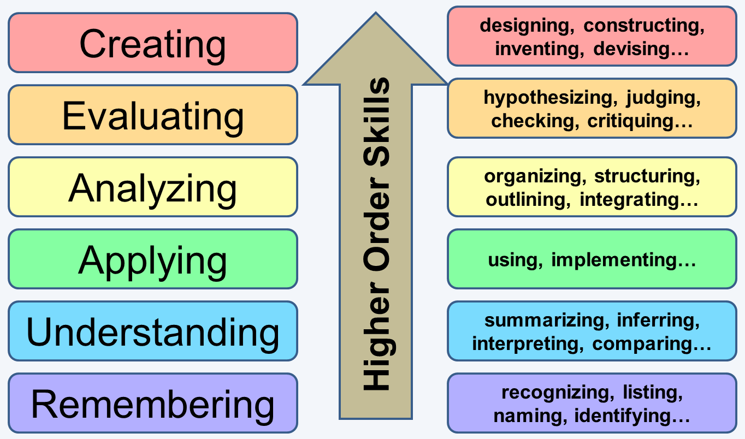
1. The first level of Bloom’s Taxonomy is to Remember.
Example activities at the Remembering level: memorize a poem, recall state capitals, remember math formulas
2. The second level of Bloom’s Taxonomy is to Understand.
Example activities at the Understanding level: organize the animal kingdom based on a given framework, illustrate the difference between a rectangle and square, summarize the plot of a simple story
3. The third level of Bloom’s Taxonomy is to Apply.
Example activities at the Application level: use a formula to solve a problem, select a design to meet a purpose, reconstruct the passage of a new law through a given government/system

4. The fourth level of Bloom’s Taxonomy is to Analyze.
Example activities at the Analysis level: identify the ‘parts of’ democracy, explain how the steps of the scientific process work together, identify why a machine isn’t working.
5. The fifth level of Bloom’s Taxonomy is to Evaluate.
Example activities at the Evaluation level: make a judgment regarding an ethical dilemma, interpret the significance of a given law of physics, illustrate the relative value of a technological innovation in a specific setting—farming, for example.
6. The sixth and final level of Bloom’s taxonomy is to Create.
Example activities at the Creation level: design a new solution to an ‘old’ problem that honors/acknowledges the previous failures, delete the least useful arguments in a persuasive essay, write a poem based on a given theme and tone.
The second stage is catering to a student’s learning abilities. A teacher’s soft and hard skills will be needed at this point. The soft skills are personal attributes that enable someone to interact effectively and harmoniously with other people. Intangible and professional attitude such as communication, leadership, collaboration, team-building, creative and critical thinking, self-motivated, responsible, problem solver, decisiveness, work ethics, flexibility with the ability to work under pressure. Hard skills are the qualifications and expertise in an environment with tangible and technical skills (https://www.thebalancecareers.com/teaching-skills-list-2062488). As a teacher the soft and hard skill must adapt to the needs of different student’s learning styles, age and ability to communicate with the students, parents, administrators, staff and colleagues. Some people are naturally patient, but a level of maturity and emotional control can be learned and must be practiced.
Growth-motivate personal gain with Maslow’s Hierarchy of Needs
Maslow wanted to understand what motivates people. His interest was driven by personal and shared experience. During the 1950s he founded and drove forces behind the thought known as humanistic psychology with theories including the hierarchy of needs, self-actualization and peak experiences as fundamental subjects in the humanist movement (Very Well Mind 2019)... He believed that individuals possess a set of motivation systems unrelated to rewards or unconscious desires. Maslow (1943) stated that people are motivated to achieve certain needs. When one need is fulfilled a person seeks to move to the next one, and so on. Maslow (1943 and 1954) stated that people are motivated to achieve certain needs and that some needs take precedence over others. Our most basic need is for physical survival, and this will be the first thing that motivates our behavior. Maslow (1943) initially stated that individuals must satisfy lower level deficit needs before progressing on to meet higher level growth needs. However, he later clarified that satisfaction of a needs is not an “all-or-none” phenomenon, admitting that his earlier statements may have given “the false impression that a need must be satisfied 100 percent before the next need emerges” (1987, p. 69). From the bottom of the hierarchy upwards, the needs are: physiological, safety, love and belonging, esteem and self-actualization. Needs lower down in the hierarchy must be satisfied before individuals can attend to needs higher up.
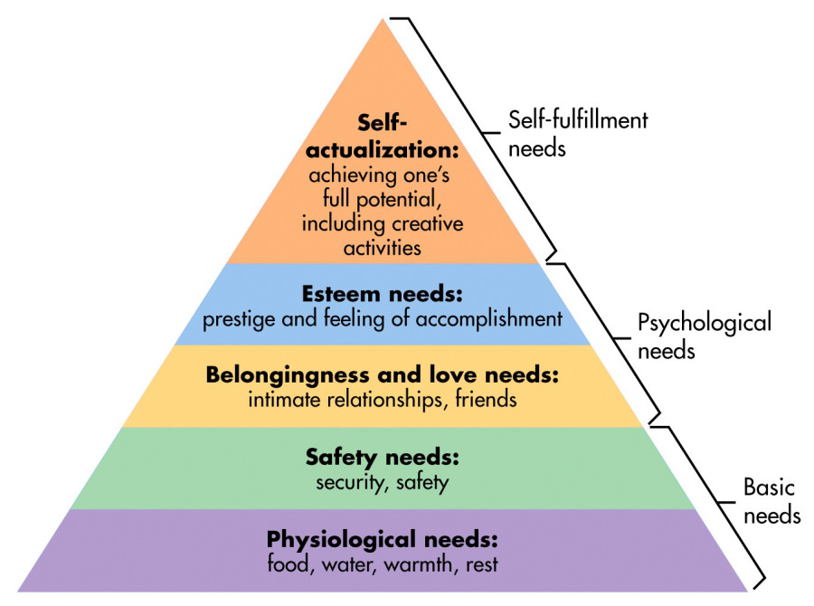
(a) human beings are motivated by a hierarchy of needs.
(b) needs are organized in a hierarchy of prepotency in which more basic needs more or less are met (rather than all or none) prior to higher needs.
(c) the order of needs is not rigid but instead may be flexible based on external circumstances, environment or individual differences.
(d) most behavior is multi-motivated, that is, simultaneously determined by more than one basic need.
- Psychological-survival
- Safety-protection
- Belonging and love-family and friends
- Self-esteem-self and respect
- Cognitive-knowledge and understanding
- Aesthetic-beauty balance form
- Self-actualization-personal growth, fulfillment, potential
- Transcendence-mystical, aesthetic, sexual
The growth stages signify the progress of the teacher and student’s achievement for the school year. These steps, stages and levels should help establish productive success for each student’s learning skills and styles.
4/3/19 The motivation and transformation to implement success is essential in developing a student’s learning skills and styles by grade levels. Texas education is ranked 43rd in the nation falling from 39th from last year addressed in education publication Education Week. Texas earned a C grade while the nation earned a C (Anderson, El Paso Times 2016). Texas Academic Performance Report 2017-18 reported Houston ISD not rated because of Harvey Provision and needs intervention for Special Education Determination Status. The STAAR testing from 3rd-12th grade levels rated by state-77%, region04-77% and district-70% with all subjects.
Start New Decade:2020
The Smithsonian Science Education Center (SSEC), formerly the National Science Resources Center, US Department of Education invested in innovation i3 program to match funds from private sectors for the study of LASER i3. Houston ISD was awarded the LASER i3 programs for a five-year term to evaluate the LASER model’s efficacy in a systemic transforming science education program. Laser i3 is a study conducted by the Center for Research in Educational Policy (CREP) at the University of Memphis on student performance at schools implementing the LASER model (Figure 1). The study found the inquiry-based science LASER model improved achievement in science, reading and math. The role helps student’s learning among underserved populations, economically disadvantage, special education and English language learners. The LASER model has five elements that plan and share vision for science, form infrastructure for student=centered learning and teaching.
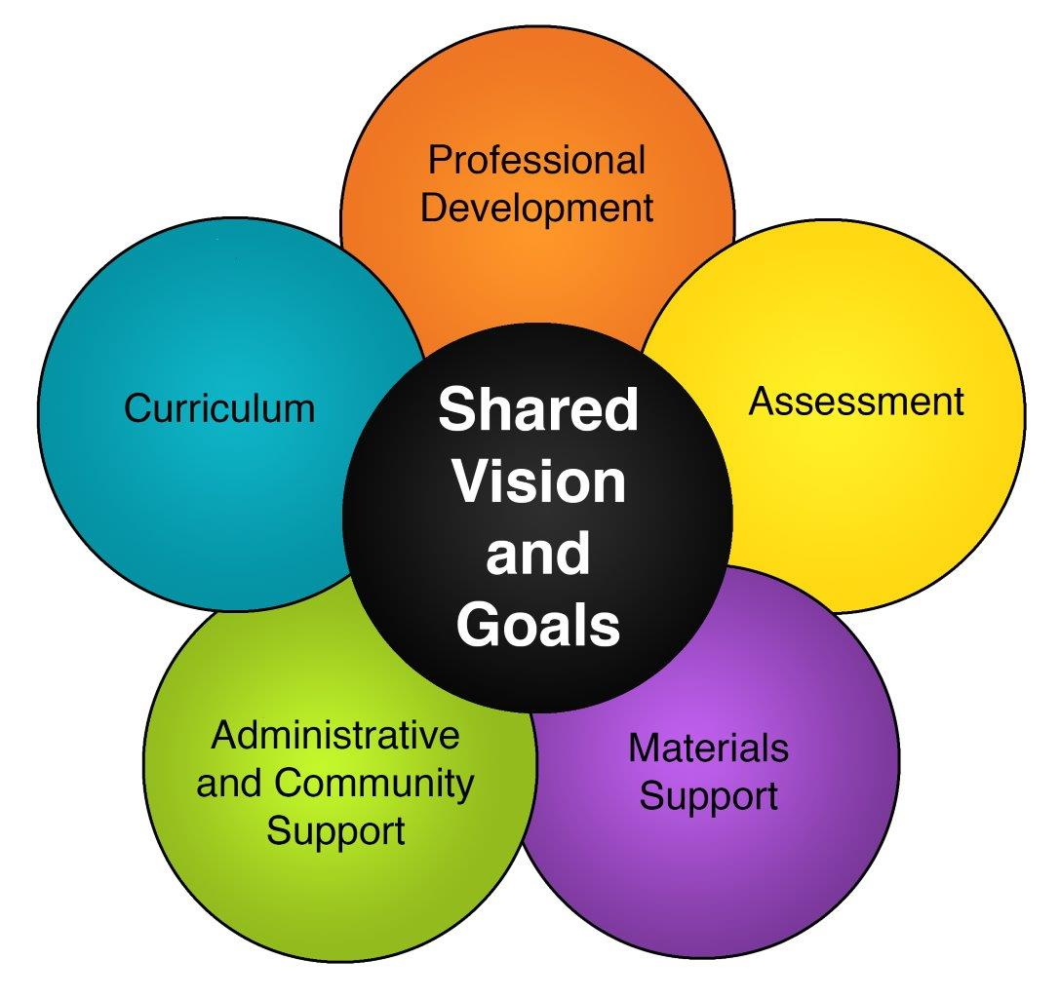
The LASER i3 improves student achievement and abilities on a research-based inquiry, student-centered curriculum, measure impact on student learning, state, district and campus assessment, professional development, materials support, administrative and community support.

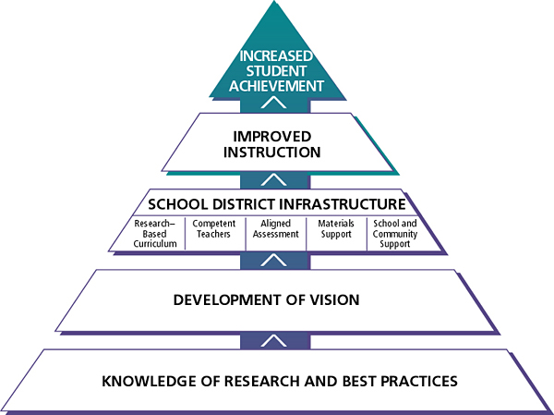
The theory on inquiry-based approach provides students captivating, first-hand learning for scientific based research and best practices to inform the development of a shared vision and infrastructure for transforming science education.
The study analyzed the impact of the LASER model on students and teachers in three states, New Mexico, North Carolina and Texas from 2010-15. It has reached 60,000 students with outcomes based on 9,000 students within two cohorts, Elementary and Middle schools. HISD implemented the LASER i3 in Elrod Elementary and Carnegie Vanguard High School.
TEA Teacher Assessment
Texas Examination of Educator Standards (TExES) requires teachers to take an assessment on early childhood (EC)-12 grade level testing after passing their educational content test. The test is designed to assess the test taker the knowledge and skills that an entry level educator in Texas public schools must possess (PPR EC-12). The 100 selected response questions are based on the Pedagogy and Professional Responsibilities (PPR) framework covering grades EC–12.
Domain I: Designing Instructional and Assessment to Promote Student Learning. The competencies reflect the understanding of relevant contents based on continuous and appropriate assessment of Piaget, Bloom and Gardner. Bloom and Gardner are discussed in Retrofit Educational Basic Skills teacher’s toolkit. Jean Piaget (1896-1980) is a psychologist known for his work on child development. Piaget's theory of cognitive development and epistemological view are called "genetic epistemology" (McLeod 2018). Piaget (1936) was the first psychologist to make a systematic study of cognitive development. According to Piaget, children are born with a very basic mental structure (genetically inherited and evolved) on which all subsequent learning and knowledge are based. The beginning teacher will develop the typical stages of cognitive, social, physical and emotional development of students in EC-12 grades. Recognize and analyze ways of learning, performance and apply knowledge to plan an effective learning experiences and assessments. Recognize factors affecting the social and emotional development of the students.

References
120 Years of American Education: Statistical Portrait, January 1993, Thomas D. Snyder Center for Education Statistics, Editor, https://nces.ed.gov/pubs93/93442.pdf. retrieved January 23, 2019.

A Half-Century Of Learning: Historical Census Statistics On Educational Attainment in the United States, 1940 to 2000, April 2006, Tables 7, 11 and 13, www.census.gov/library/publications/2010/demo/educational-attainment-1940-2000.html, retrieved January 23, 2019.

Anderson, L., January 10, 2016, Texas falls to 43 in National Education Ranking, El Paso Times, https://www.elpasotimes.com/story/news/education/2016/01/10/texas-falls-43-national-education-ranking/78519596/, retrieved April 2, 2019

Bloom’s Taxonomy A Classification of Cognitive Processes, A Purpose of Education is the Development of Student "Thinking" Skills, EZSnips,
http://ezsnips.squarespace.com/blooms-taxonomy/, retrieved January 24, 2019.
Cherry, K., March 9, 2019, Biography of Abraham Maslow 1908-1970, Very Well Mind, https//www.verywellmind.com/biography-of-abraham-maslow-1908-1970-2795524, retrieved March 28, 2019
Doyle, A., October 30, 2018, Teaching Skills, Lists and Examples, The Balance Career, https://www.thebalancecareers.com/teaching-skills-list-2062488, retrieved March 19, 2019.
Governing the States and Localities, Texas 2012, State High School Graduation Rates by Race, Ethnicity 2010, Table 1-2, http://www.governing.com/gov-data/education-data/state-high-school-graduation-rates-by-race-ethnicity.html, retrieved January 23, 2019

Isensee, L., August 7, 2017, Dozens of Texas Districts Must Improve Failing Schools – Or Outside Managers Could Take Over, Education News,
https://www.houstonpublicmedia.org/articles/news/2017/08/07/228974/dozens-of-texas-districts-must-improve-failing-schools-or-outside-managers-could-take-over/, retrieved February 4, 2019.
Kashatus, W., May 8, 2011, Howard Gardner’s Theory of Multiple Intelligence Inspires Many in Education, The Citizen’s Voice, https//www.citizensvoice.com, retrieved March 28, 2019.
McLeod, S., 2007 updated 2018, Maslow's Hierarchy of Needs, Simply Psychology, http://rocket.csusb.edu/~tmoody/Maslow%27s%20Hierarchy%20of%20Needs%20%20%20Simply%20Psychology.html, https://www.simplypsychology.org/maslow.html, retrieved January 24, 2019 and March 19, 2019..
Miller, J., Gotta Maslow Before You Bloom, The Education Room, Empowering Teachers as the Experts, https://theeducatorsroom.com/gotta-maslow-bloom/, retrieved January 24, 2019.
Multiple Intelligences, https://www.tecweb.org/styles/gardner.html, retrieved March 19, 2019.
Preville, P., July 4, 2018, Bloom’s Taxonomy: A History and Why It’s Important, , https://tophat.com/blog/blooms-taxonomy-history-important/, retrieved March 28, 2019.
Swaby, A., January 3, 2019, Governor Abbot Advocates the Takeover of HISD in a Tweet, https://www.texastribune.org/2019/01/03/texas-gov-greg-abbott-take-over-houston-isd/, retrieved February 4, 2019.
Texas Academic Performance Report, 2017-18, Texas Education Agency, District STAAR Performance, Houston ISD, https//rptsvr1.tea.texas.gov, retrieved April 2, 2019

Webb, S., August 14, 2018, How Houston Area Districts Fared: TEA Releases STAAR Results, Accountability Grades, Houston Chronicle, https://www.houstonchronicle.com/news/education/article/TEA-to-release-STAAR-test-results-accountability-13155977.php, retrieved February 4, 2019.
What is Your Learning Style? 20 Questions, Education Planner.org, http://www.educationplanner.org/students/self-assessments/learning-styles-quiz.shtml, retrieved January 24, 2019.

Half-Century of Learning: Historical Census Statistics on Education Attainment, Figure 1’Tables 7,11 and 13, and Figure 2; page 3, Education Characteristics Percent of Population with High School Diploma from Both Sexes in Texas.
Maslow’s hierarchy is a heckuva ladder to climb. Jake Miller, Gotta Maslow Before You Bloom, https://theeducatorsroom.com/gotta-maslow-bloom/, The Education Room, Empowering Teachers as the Experts.
Id
The article argued that the district should get lawmakers to repeal that law and sue the state's education agency if the Legislature refuses. Governor Abbot advocates the takeover of HISD in a tweet, A. Swaby, January 3, 2019, https://www.texastribune.org/2019/01/03/texas-gov-greg-abbott-take-over-houston-isd/.
News 88.7 analyzed state data and found more than forty districts that could see an outside board of managers as early as next year, if they don’t improve their chronically failing schools. L. Isensee, August 7, 2017, https://www.houstonpublicmedia.org/articles/news/2017/08/07/228974/dozens-of-texas-districts-must-improve-failing-schools-or-outside-managers-could-take-over/.
Id
Half-Century of Learning: Historical Census Statistics on Education Attainment, Figure 1’Tables 7,11 and 13, and Figure 2; page 3, Education Characteristics Percent of Population with High School Diploma from Both Sexes in Texas
Residential segregation by jurisdiction generates disparities in public service and education. The distinctive American pattern-in which blacks live in cities and whites in the suburb-was enhanced by a large black migration from the rural South (Bousain, M. February 2010).
Enrollment by ethnicity shifted from 1968-69 to 1999-2000. The largest groups of students were Whites from 1968-69 to 1972-73, African Americans from 1973-74 to 1988-89 and Hispanics 1989-90 to 2001-02 (The HISD Digest of Education Statistics).
Data for this digest were collected from numerous sources, HISD School Administrative Student Information (SASI), Texas Education Agency (TEA), TEA Public Education Information Management System (PEIMS), Texas Assessment of Academic Skills (TAAS), Human Resource database, Harcourt Brace data tapes and Educational Testing Service data tapes (Chapter 2 Enrollment, Table 2.1, Page 9).
HISD.org Facts and Figures 2015-16 school year.
Id.
HISD leaders instituted drastic changes at some campuses. Principals were replaced at 12 of the 18 highest-need schools at the beginning of or during the school year. Some low-rated teachers were jettisoned, highlighted by two-thirds of the teachers at Woodson K-8 and Worthing HS, two of the worst-performing schools. Jacob Carpenter, HouChron, June 22, 2018.
Early results show big gains for HISD turnaround schools. Jacob Carpenter, HouChron, June 22, 2018.
Challenge an educational system that assumes everyone can learn the same materials the same way that are uniform, universal measures suffices to test student learning. Multiple Intelligences, https://www.tecweb.org/styles/gardner.html, to carry out different tasks, solve diverse problems and progress in various domains.
Your learning style influence the way you understand information and solve problems. What’s Your Learning Styles, http://www.educationplanner.org/students/self-assessments/learning-styles.shtml, explore and discover a student’s interest.
Ironically, Bloom and his colleagues intended for the taxonomy to be included in higher education, it took deeper roots in K-12. Bloom’s Taxonomy: A History and Why It’s Important, Philip Preville, July 4, 2018, https://tophat.com/blog/blooms-taxonomy-history-important/, history and origin its future in classrooms that are dominated by technology.
There are many purposes of education, one of which is to help guide the development of our "thinking" skills as we move through our educational experiences, we come to better understand the world around us. Bloom's Taxonomy - A Classification of Cognitive Processes, http://ezsnips.squarespace.com/blooms-taxonomy/, the development of student “thinking” skills.
Many skills are required for a teaching job depending on the school and grade you are teaching, there are several skills needed for any teaching position. Teaching Skills Lists and Examples, https://www.thebalancecareers.com/teaching-skills-list-2062488, for careers.
Maslow's hierarchy of needs is a motivational theory in psychology comprising a five-tier model of human needs, often depicted as hierarchical levels within a pyramid. Maslow’s Hierarchy of Needs, Saul McLeod, 2018, https://www.simplypsychology.org/maslow.html, can be divide into deficiency and growth needs.
Id.
Laser i3 Houston ISD, in 2010 the US Department of Education awarded the SSEC five-year investment in innovation validation grant to comprise 43.8% of the population. www.ssec.st.edu/laser-13-houston-independent-school-district,
Id
Id
Piaget's (1936) theory of cognitive development explains how a child constructs a mental model of the world. Simply Psychology, https://www.simplypsychology.org/piaget.html, Saul McLeod 2018

