Foster Place Housing Characteristics Study for Aging in Place
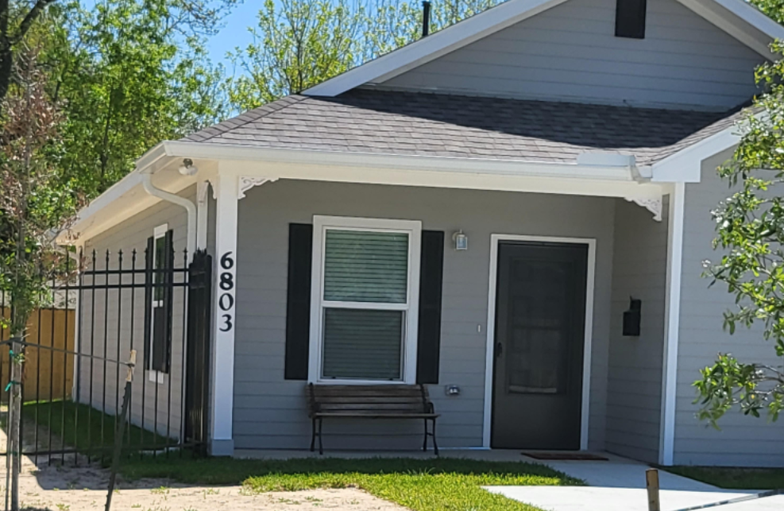

Neighborhood Recovery CDC
Phase I-Final Housing Characteristics Study
Andret Rayford, GO Housing Team
Darius Williams, Intern
May 4, 2022

Foster Place Housing Characteristics Research Report
The OST/SU residents are aging in their homes, living longer, active, and productive lives. The homes and infrastructure are aging and need reconstruction for aging adults to live comfortably and independently.
By 2030, more aging adults are projected to outnumber the demographic group aged under 15 (Census, CB18-41,2018). The 2000 census reported 35.5 million people aged sixty-five and older increased by 12% in the 10 years before. Aging adults represent 12.4% of the total population and estimated to grow by 20% by 2030.
Phase I-Foster Place’s housing characteristic study addressed physical barriers such as, infrastructure and transit networks. The housing data includes vacant plats, average housing square footage, land, improvement, and market value, 5-year appraisal trends, year homes built, remodeling and new construction. The community’s new construction is building frequently with 3-story townhomes, single-family homes, and Texas General Land Office (TX GLO) Harvey Program homes.
Phase II-the study will continue with the housing research on South Union budget request. After Phase III-LaSalette, we will create a small neighborhood ancestry plan (SNAP) to educate residential families on how to develop a design concept for affordable housing options, AMOS, opportunity for walking, biking transit options, physical activities, health, and supportive services featured for age-friendly community readiness and engagement
The goal to quantify and understand qualitative elements for meeting individual’s need of aging, mobility, accessibility, and safety. The need to meet residents with objectives to measure what aging in place and ancestry planning community looks by meeting the needs of community residents and generational wealth. Residential communication and concerns with newly built development creating changes with the community’s fabric.
History of M. E. Foster Place

The origins of Foster Place, Houston Texas began in 1949 where homes were developed and sold, by a visionary and developer named M. E. Foster, President of Texas Avenue Realty, Company (Julia Ideson, Houston Public Library). Foster advertised the community’s development in 1942 Houston Chronicle home section, as a desirable residential community with modern convenience. Foster Place was designed to overlook the artistic Rice Institute building, beautiful residences and hotel apartments in the Circle, Herman Hospital over the winding road of Herman Park, Feldman Court, Washington Terrace, Riverside Terrace and the skyline of Houston city views (Foster Place, Information File, Houston Public Library) (see Figure 1).

The neighborhood began with 745 single-family units ranging from $20-57,000. The amazing investment had an opportunity in a high price location with home-owing and home-building in Houston. Those who decide, and act quickly will profit by the “before competitive prices”-ACT Today! (Houston Chronicle 1942)
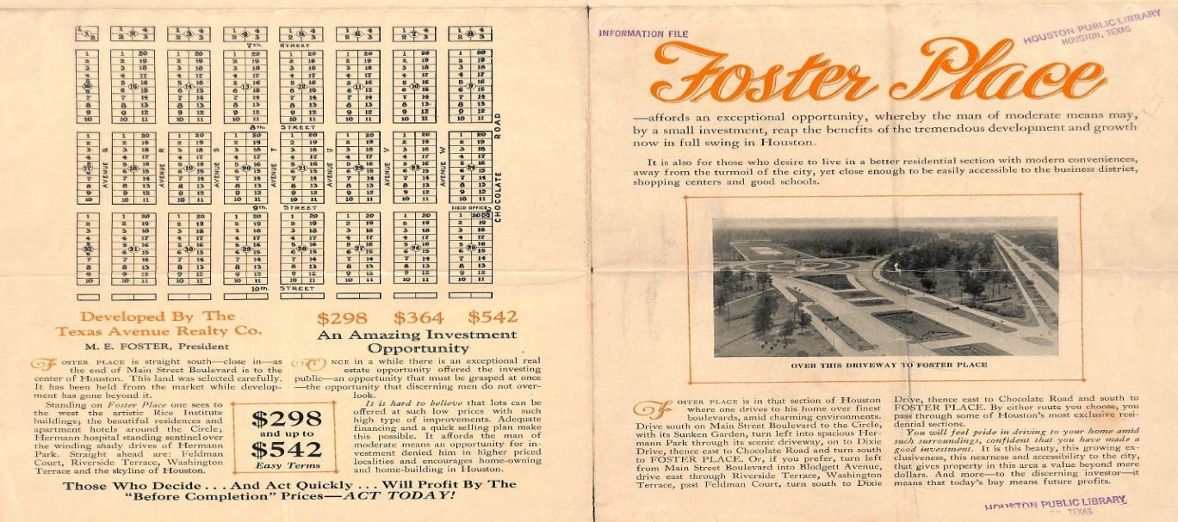
Figure 1: Source: Foster Place, Information File, Houston Public Library, September 12, 2018

Founder of Foster Place

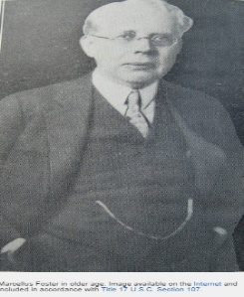
FOSTER, MARCELLUS ELLIOT (1870–1942), news reporter and businessperson, was born in Pembroke, Kentucky on November 29, 1870, the family moved to Huntsville, Texas in 1873 (Lucko 2011). Foster graduated from Sam Houston Normal Institute (now Sam Houston State University) in 1890. He also studied at the University of Texas in 1891–92. M. E. Foster grew up in poverty and empathized with the working laborers (Lucko 2011). He authored an article “scolding corporations for not having empathy for the working class”.
Image 1: Marcellus Foster older age, image Internet included accordance title 17 USC, Section 107

In 1901, Marcellus E. Foster established the Houston Chronicle, which he controlled until 1926. He was editor of the Houston Press when he died in 1942. M. E. Foster Elementary school was built in his memory (Lucko 2011). Foster wrote under the pen name “Mefo”, entitled his daily column "Our City." In Houston, Foster was President of the Texas Avenue Realty Company, the University Land Company, the M. E. Foster Properties Company, director of the City National and Seaport National banks and the Standard Fire Insurance Company. After his career of fifty years in journalism, he retired in March 1941. At a farewell dinner attended by former governors William Hobby and James Allred, Foster voiced his conviction that "Texas could be no great success without the work of the little men. Those who go to the factories or to the great stores of the country earn their small wages and return to their families satisfied and contented." (Lucko 2011 pg. 1).

M. E. Foster visualized the Foster Place area as the finest boulevard with a charming environment. In 1942, this Houston’s exclusive residential community was viewed as a charming development. The residents took pride driving into this new community’s beautification and exclusivity of low housing investment, buying power and future profit (Julia Ideson, Houston Public Library).

Figure 2: Foster Place www.neighborhoodscout.com
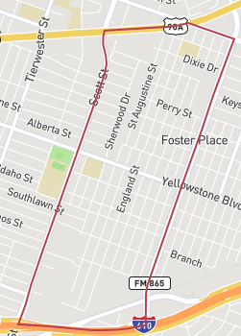
Foster Place traditional Craftsman’s designed homes remain with a charming family-oriented environment. Foster Place, Houston, Texas 77021, an urban community in Southeast Houston area. Figure 3 illustrates the boundaries (ERSI ArcGIS 2017) from Scott Street, Yellowstone Street, Cullen Street and Holmes Road characteristics with 4,828 residents, 1,882 housing units, 55% homeowners with 1,150 square feet (more/less) homes on 5,150 square feet lot size. See Figure 2 (neighborhoodscout.com) is the plat area in Southeast Houston where 1949 home structures remain and some reconstructed housing units (HCAD 2017).
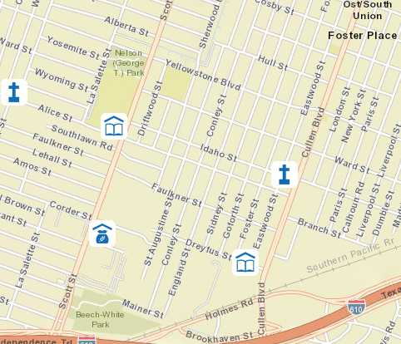

There are two educational institutions, (figure3), M E Foster Elementary (1942) and Cullen Jr. High (1993) schools, three churches, St. Mary’s Methodist, New Solid Rock and New Bright Star Baptist in the neighborhood with 111 vacant lots (Census.gov).

Figure 3: Foster Place Community, ERSI ArcGIS 2018

Foster Place Natural and Built Environment

The neighborhood’s housing units had 41% of owner occupied, 61% renters, housing average value of $11,000 and average contract rent was $112. Houston’s homeowner occupancy was 49%, renters 44%, average housing value was $18,300 an average contract rent was $109. Land-use operations in Foster Place had 42% residential, 18% commercial, 9% industrial and 25% undeveloped with major land-use. Census of Population and Housing - Publications - U.S. Census Publication... http//:www.census.gov has information on Harris County from 1950-2010

The communities South Park/Foster Place/MacGregor profile was developed by the Houston City Planning Department designated by the mayor’s office (Data Book 1976). The Houston Mayors, during the growth of these three communities combined and became Target Area 19. Chart 1: Demographics in Foster Place (1970 Census of Population & Housing).

The census tracts and the chart below illustrate the age groups population in 2016 (Census.gov 2016). Foster Place has change with the age group and decreased in population. The current 2016 age cohorts are shown on Chart 2.

Aged cohorts | 50-59 | 60-64 | 65-69 | 70-74 | 75-79 | 80-84 | 85- over
Population | 547 | 196 | 174 | 178 | 129 | 91 | 64

Chart 2: Source: http://www.usboundary.com/Areas/Census%20Tract/Texas/HarrisData 2018

Transportation used two bus routes to serve the community (Data Book 1976). The streets were in good condition-10% rated poor and others rated good or fair. Most of the streets were built with concrete or asphalt (1970 Census of Pop & Housing). Other public facilities in the community consisted of George T. Nelson (Yellowstone) Park with 5.9 acres of land with shelter, playground equipment, picnic area, softball area and neighborhood swimming pool.

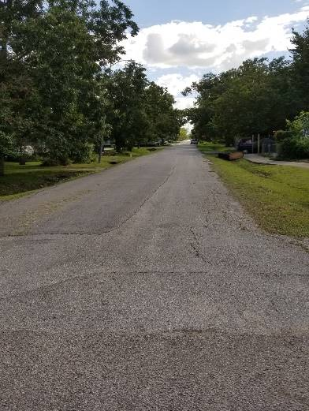
A road survey was done in 2014 by Urban Planning and Environmental Policy (UPEP) students and Dr. Sheri Smith, UPEP professor at Texas Southern University (TSU) for the Southeast Houston Community Neighborhood Recovery CDC. The results showed much needed repair on many of the streets. After 7 years the streets are still in need of major repairs and pavement resurfacing (see picture St. Augustine and Idaho). The roads and sidewalks are more cracks, buckles, and unleveled areas, swirling and dodging cars from damage road conditions and streets without sidewalks.

School aged children walking from Cullen Middle School up Alice Street must walk several blocks before reaching a sidewalk. The danger of cars on a two-way street and giving right-way to pedestrians is quite daunting. As a novice planner being able to advocate for better housing, roads and sidewalk improvements in the neighborhood is vital for functional infrastructure with “aging in place”.

Foster Place Growth or Decline in the Aging Community
In 2017, Houston’s median resident age was thirty-four, median income $34,565, household size 2.5, households with mortgage $1,794, residents below poverty line 27.3 (city-USAdata.com 2017). Foster Place vacancy rate is 14.2%, numerous homes and lots are abandoned or unkempt to date. The city data reports a community’s size under 7,000 residents are considered small.
Chart 3 gives the average mortgage for a resident in Foster Place community of $1,100 as of 2018.
Current | Median | Average | House | Rooms | Baths
MKT value | Sale price | $ per Sq. ft. | Square feet | Bedroom | Bathroom
$95-140,000 | $75,000 | $105 | 692-1,992 | 2-4 | 1-3

Chart 3: www.neighborhoodscout.com 2018
The signs to notice when a Black community shows slow changes that become gradual moves to the neighborhood’s majority of residents being displaced and relocated (Richards 2018). The five signs are: historical underinvestment of the neighborhood’s character, land speculation with developers purchasing land but no developing happening, ongoing demolitions with teardowns and many vacant lots in the community, rapid market-rate development beginning at a rapid pace and displacement of long-time residents moving or transitioning in the community.

Housing Characteristic Study 2022

The Foster Place neighborhood study revealed a notable and unique area with its homes and settings. Same place with a different look. The homes are wood frame on blocks with driveways, sidewalks, unattached garages, and noticeable wear and tear. The new construction on the cover page is located at 6803 Goforth and Ward, built with hardie plank siding, sidewalk, and driveway. New constructions are changing the fabric of the neighborhood with 3-story townhomes, new brick or hardie plank siding single-family homes, and 2-story duplexes.

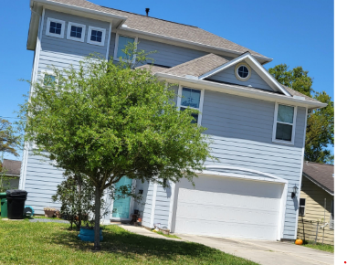
A newer home built in 2016, is located at 6706 St. Augustine, a 2409 square footage, 3-story single family home, market value $182,267, on 5,150 land area/$46,350. As of January 1, 2022, the market value is $200,493 with land value of $72,100.

Growing up in the neighborhood I have seen the area changing which brought about this housing characteristic report. While attending OST/SU meetings and becoming the housing GO Team leader the observation was necessary.

The data for the 5-year analysis of Foster Place’s 2017-21 results from Harris County Appraisal District (HCAD) shown below from varies streets in the neighborhood. The data collected single-family wood frame homes built in the 1940’s with the square footage of 776 to 1754 with five rooms (1 or 2 bedrooms, 1 or 2 baths, living room, and kitchen) and unattached garage/sheds. The effect of land value increase causes the market value to increase and taxes to also increase for homeowners in the neighborhood.
Address | House |  | Square Footage |  | Type | Tax Delinquent |  |  | Year Built | Current Market value | Current Land value |  | Improvement |  | Owner Occupied | Land Area SF | Appraisal 17 | Appraisal 18 | Appraisal 19 | Appraisal 20 | Appraisal 21 | Home Units
Dreyfus | 4010 |  | 5100 |  | vacant-c1 |  |  |  |  | 45900 | 45900 |  |  |  | n | 5100 | 12750 | 12750 | 17850 | 25500 | 30600 | 45900
 | 4014 |  | 2720 |  | twofam-b2 |  |  |  | 2018 | 266835 | 46350 |  | 220485 |  | n | 5150 | 12875 | 12875 | 18025 | 220527 | 223729 | 266835
 | 4022 |  | 0 |  | vacant-c1 |  |  |  |  | 39899 | 39899 |  | 0 |  | n | 5075 | 12688 | 12688 | 17763 | 19125 | 26593 | 39899
 | 4026 |  | 0 |  | vacant-c1 |  |  |  |  | 39899 | 39899 |  |  |  | n | 5075 | 12688 | 12688 | 17763 | 19125 | 28599 | 39889
 | 4030 |  | 1140 |  | sfam-a1 |  |  |  | 1955 | 75870 | 45675 |  | 30195 |  | n | 5075 | 29117 | 36495 | 46205 | 40450 | 75870 | 75870
 | 4034 |  | 1642 |  | sfam-a1 |  |  |  | 1955 | 108835 | 45675 |  | 63160 |  | n | 5075 | 44339 | 44339 | 54120 | 68508 | 60000 | 108835
 | 4106 |  | 1290 |  | sfam-a1 |  |  |  | 1955 | 44207 | 46350 |  | 64644 |  | y | 5160 | 30196 | 30196 | 33215 | 36536 | 40189 | 44207
 | 4110 |  | 1232 |  | sfam-a1 |  |  |  | 1955 | 103947 | 46350 |  | 57597 |  | n | 5150 | 31375 | 31375 | 38937 | 60774 | 66600 | 103947
Land Area SF |  | Appraisal 17 |  | Appraisal 18 |  |  | Appraisal 19 |  |  | Appraisal 20 |  | Appraisal 21
5100 |  | 12750 |  | 12750 |  |  | 17850 |  |  | 25500 |  | 30600
5150 |  | 12875 |  | 12875 |  |  | 18025 |  |  | 220527 |  | 223729
5075 |  | 12688 |  | 12688 |  |  | 17763 |  |  | 19125 |  | 26593
5075 |  | 12688 |  | 12688 |  |  | 17763 |  |  | 19125 |  | 28599
5075 |  | 29117 |  | 36495 |  |  | 46205 |  |  | 40450 |  | 75870
5075 |  | 44339 |  | 44339 |  |  | 54120 |  |  | 68508 |  | 60000
5160 |  | 30196 |  | 30196 |  |  | 33215 |  |  | 36536 |  | 40189
5150 |  | 31375 |  | 31375 |  |  | 38937 |  |  | 60774 |  | 66600
5150 |  | 0 |  | 0 |  |  | 0 |  |  | 0 |  | 0
5075 |  | 42673 |  | 42673 |  |  | 52270 |  |  | 66400 |  | 71500
5150 |  | 12875 |  | 12875 |  |  | 18025 |  |  | 25750 |  | 30900
5075 |  | 15000 |  | 15000 |  |  | 30896 |  |  | 27000 |  | 36634
5150 |  | 12875 |  | 20600 |  |  | 25750 |  |  | 29613 |  | 29613
10300 |  | 71887 |  | 71887 |  |  | 81961 |  |  | 97000 |  | 155765
5075 |  | 38833 |  | 38833 |  |  | 47544 |  |  | 61373 |  | 65607
16300 |  | 39688 |  | 39688 |  |  | 64013 |  |  | 79375 |  | 95250
5075 |  | 12688 |  | 12688 |  |  | 17763 |  |  | 25375 |  | 30450
5075 |  | 37518 |  | 37518 |  |  | 46249 |  |  | 48349 |  | 52416
5075 |  | 38915 |  | 39653 |  |  | 43618 |  |  | 47979 |  | 52776
6000 |  | 24045 |  | 24045 |  |  | 32456 |  |  | 72853 |  | 78428
7685 |  | 45996 |  | 45996 |  |  | 56929 |  |  | 73304 |  | 79721
7725 |  | 29000 |  | 29000 |  |  | 35437 |  |  | 32188 |  | 35400

The land area on Dreyfus, 5,150 with current land value appraisal increased from 45, 675 to 46, 350, the market value appraisal fluctuates as shown by chart below from 2017-2021. The data gives tax delinquency with many homeowners’ non-homestead exemptions. Dreyfus is a smaller street in the neighborhood with eight properties vacant and a warehouse. One home construction was built with rail cars into a 2-story duplex. Another property’s 3-story townhomes with 4,316 square footages. The streets need repairing and resurfacing, while sidewalks are nonexistent.

Chart 4: HCAD appraisal trend 2017-21

Conley is a larger exterior street with one hundred homes built in 1949-1950, address 6601-7146 and 17 vacant lots undeveloped on the block. There are six estate properties recorded and many remodels ranging from 1960-2020. There are many homeowners with little knowledge of homestead exemption benefits. The built structures need repairing and resurfacing with vegetation overshadowing the sidewalks.

Chart 5: HCAD appraisal trend 2017-21

Alice is a mid-size arterial street with thirty-eight homes built in 1930-1960, square footage from 874 to 1594. The land area varies from 5,379 to 18,285 with three vacant lots and two churches. The problem with many homeowners uneducated about homestead exemption. The street needs repairing and resurfacing, sidewalks are in slightly good condition with some areas overshadowed with vegetation.

Chart 6: HCAD appraisal trend 2017-21

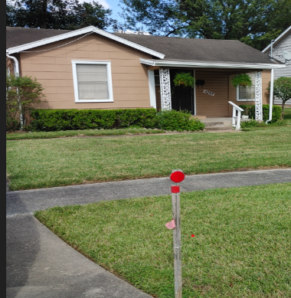
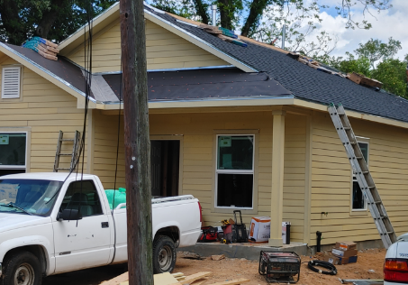
Texas General Land Office (TX GLO) has given my mom a new life. Her home needed repair with exterior foundation, plumbing, electrical, and new trend interior spaces. The home’s address at 4205 Alice, built in 1948 on 5,379 square footage of land with 1,356 home square footage. The 2021 market value of $55,592, land value of $47,351 and improvement value of $54,551. The picture shown is 30 days of construction on 1,356 square footage and new open concept interior.

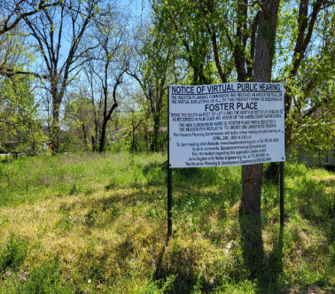
This vacant lot is located at 7118 and 7119 England with connection to 7114 Sidney vacant lot. The neighborhood has over sixty vacant lots with some vegetation, some clean and groomed, and some in new construction (see pictures below).

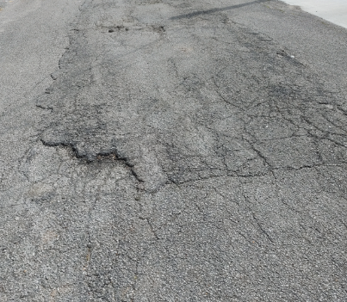
The neighborhood has many streets with unleveled, cracks, dips, potholes, and overgrown vegetation on the two-way lanes. The trend for any new home construction includes new driveways and sidewalks. The older homes are left with decayed or cracked driveways and sidewalks. Some streets do not have proper street signage or sidewalks.

Foster Elementary and Cullen Middle school students must walk in the street because of limited sidewalks for them to travel on (see illustrations below). The picture displays a crack and unleveled area on Alice and Sidney where constant car traffic continues. Many cars are subject to slow down and stop for cars passing on the left side. The two transit bus routes still exist on Scott for residents without cars. The bus stops are clean and maintained with a trash unit, seating and partitions.

Conclusion

Phase II with South Union study report tentatively completed by December 2022 on the research and focus group comments for aging in place. A Small neighborhood Aging Plan (SNAP) designs with homes natural and built environment suggestions in Foster Place, South Union, and LaSalette for agencies and elected officials to take heed. Objective indicators to measure what aging in place and ancestry planning community looks like to meet the needs of the residents and generational wealth. We will take in key factors that indicates a community’s potential for improvement over time. The research findings will develop individual preferences on the neighborhoods that one size does not fit all. The goal to quantify and build qualitative elements for meeting individual’s need of aging, mobility, accessibility, and safety. The need to meet residents with these interventions:
- Be relevant and useful to existing efforts for improvement.
- Be useful in educating family members on what needs for aging in place.
- Be mindful in educating residents on how to age in place.
- Incorporate the need for aging adults for general livability.
- Help stakeholders understand the need for aging adults and the data limitation for each neighborhood.

Illustrations

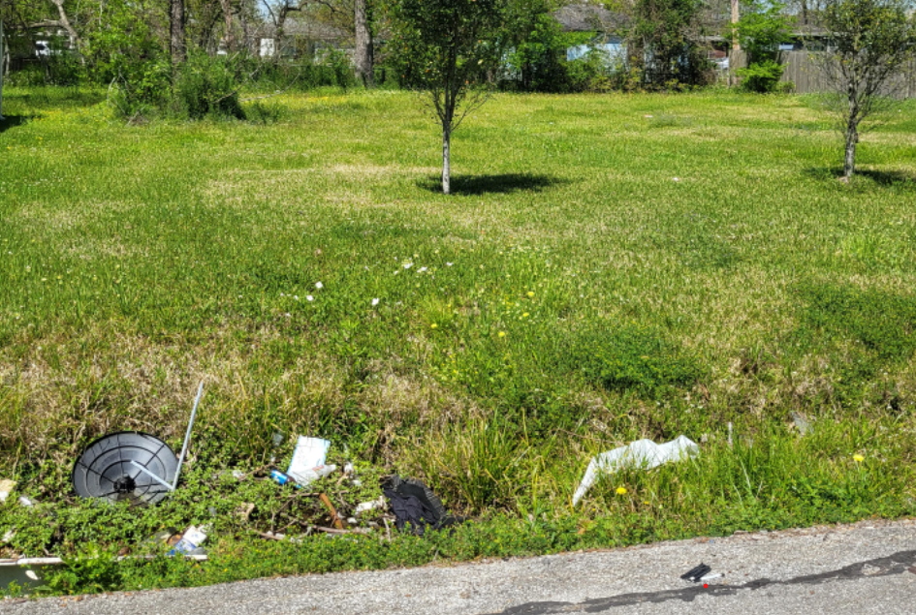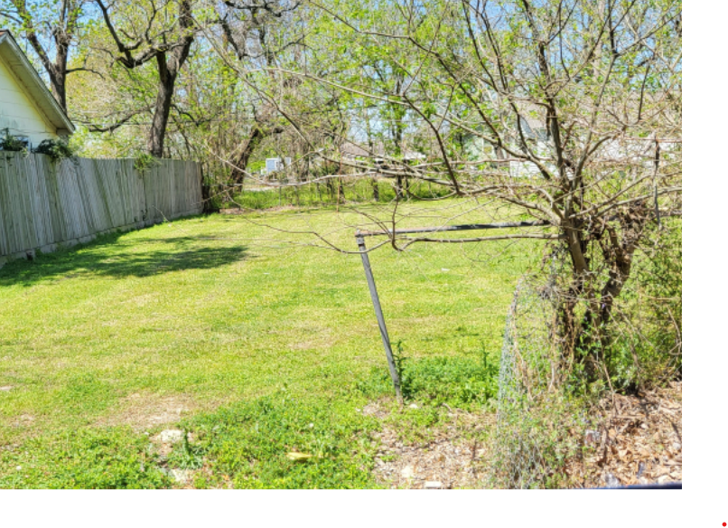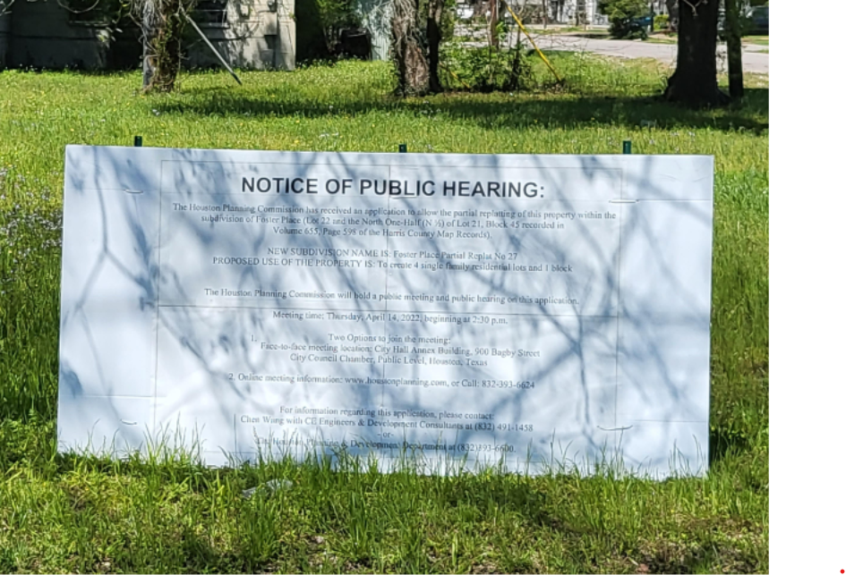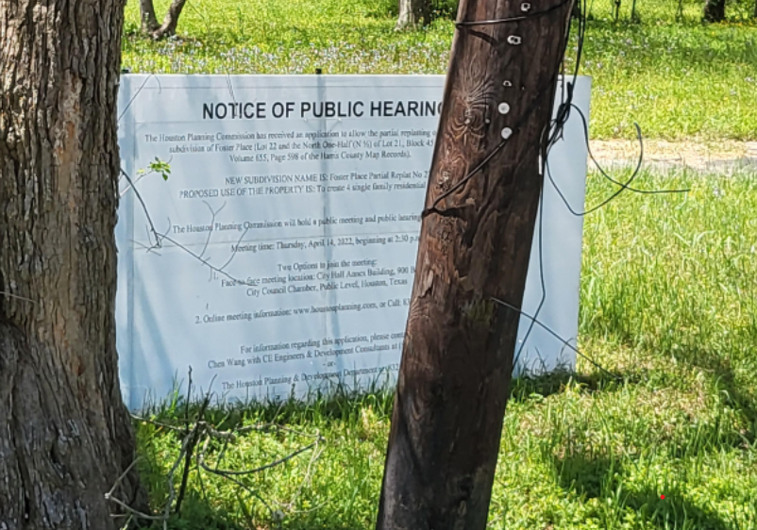

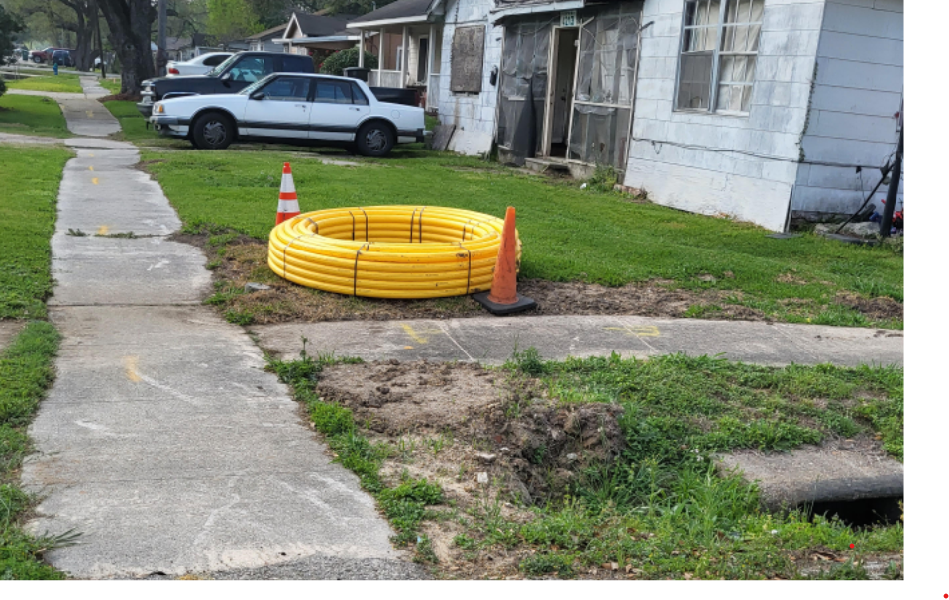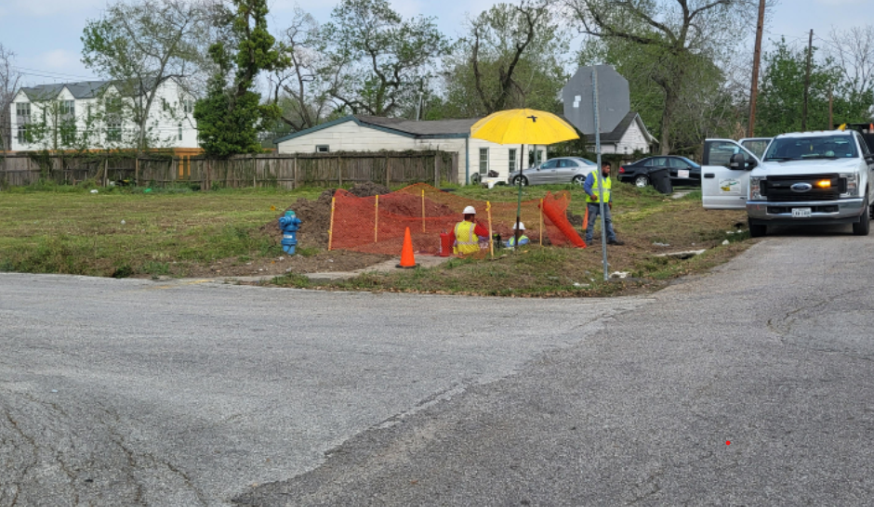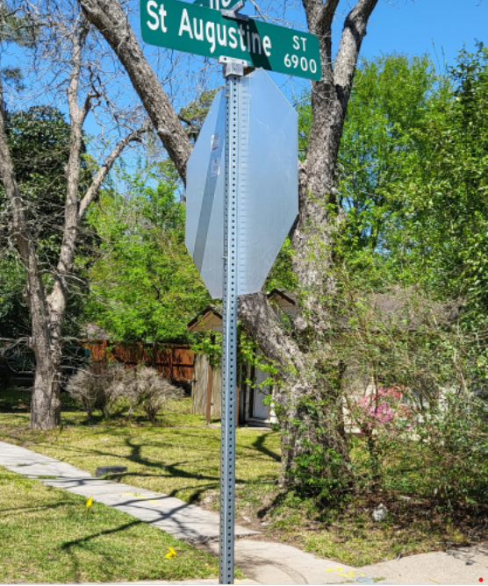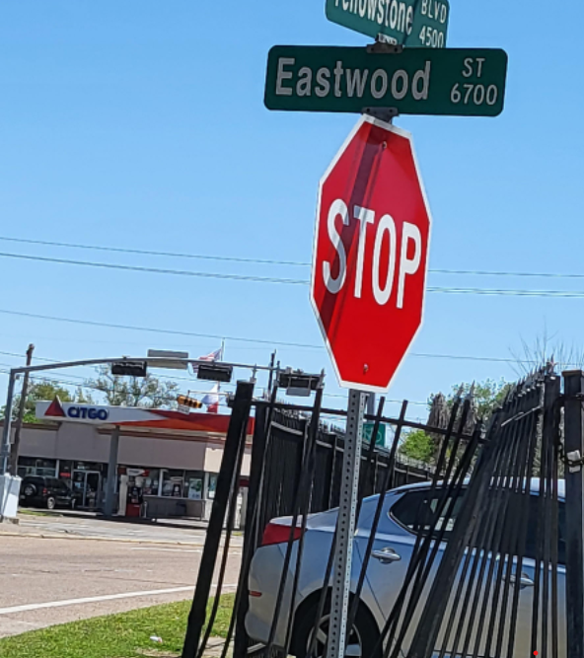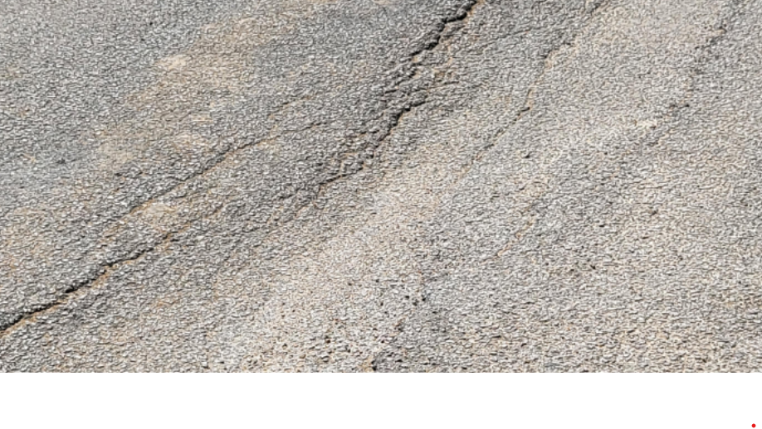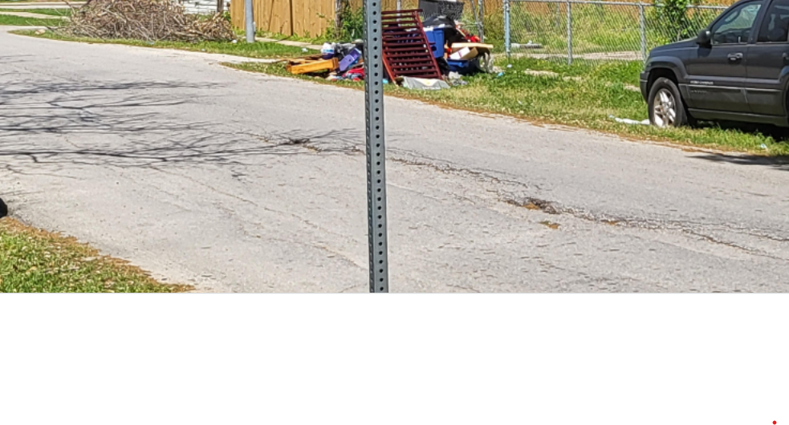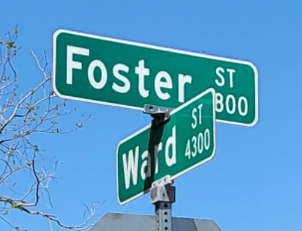

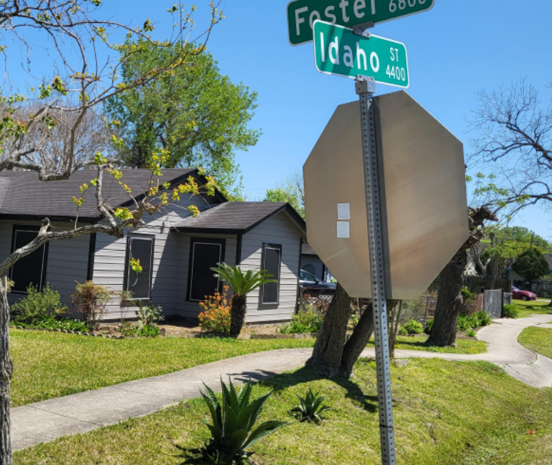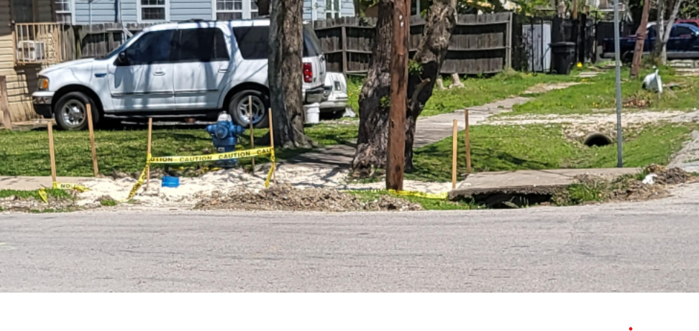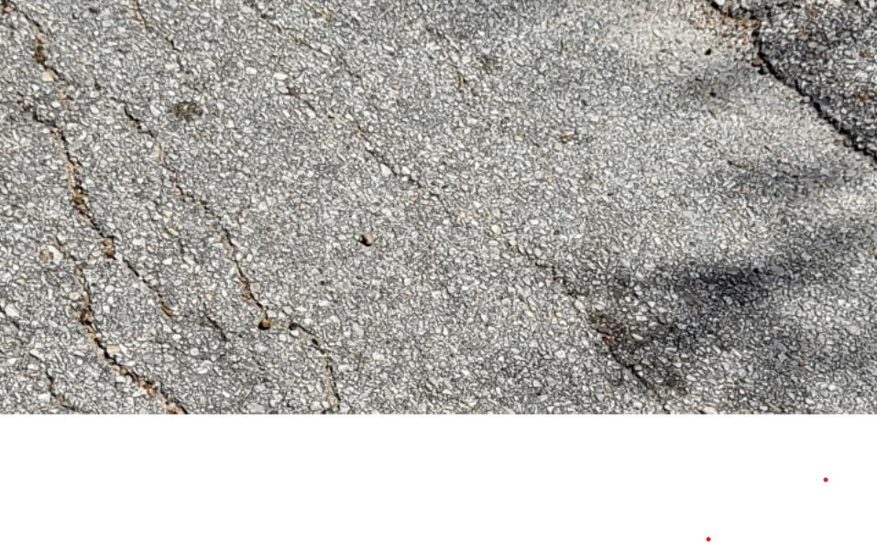

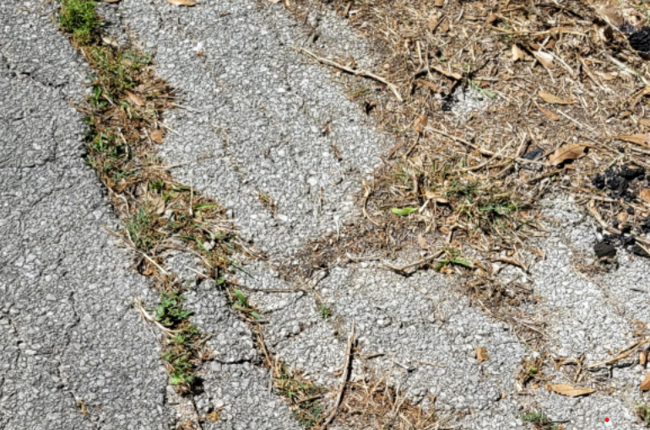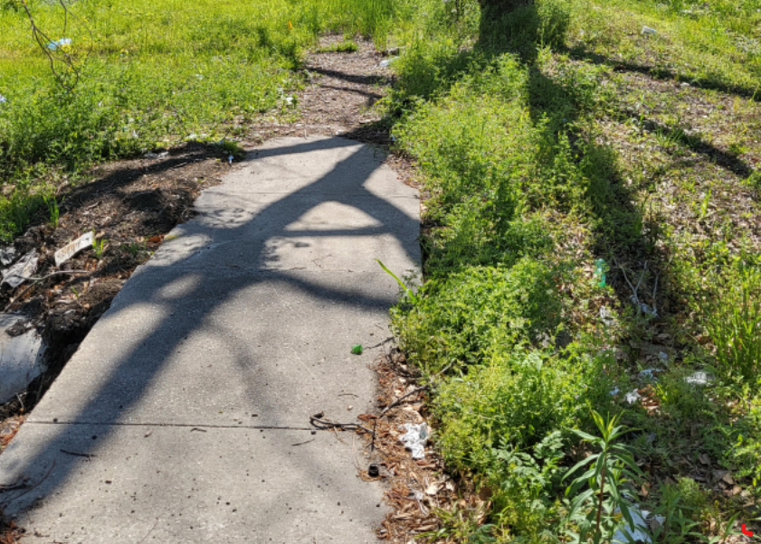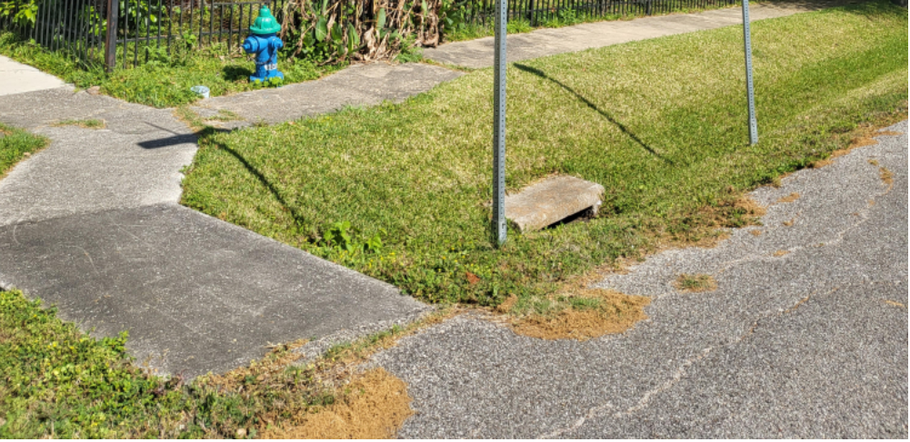

Infrastructure

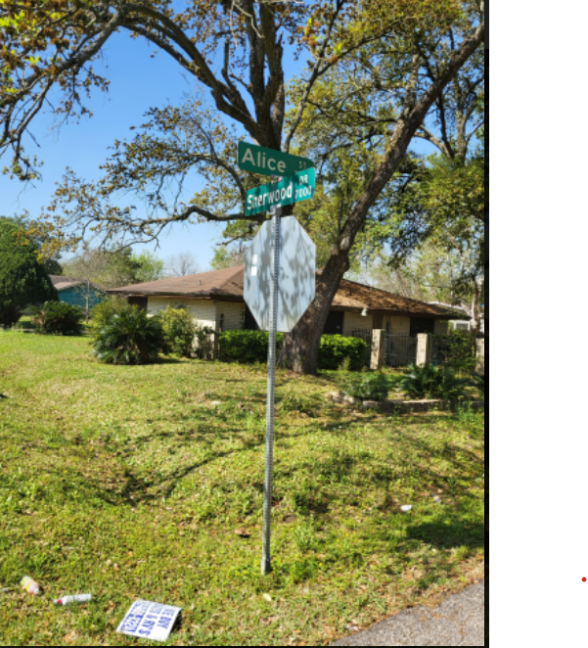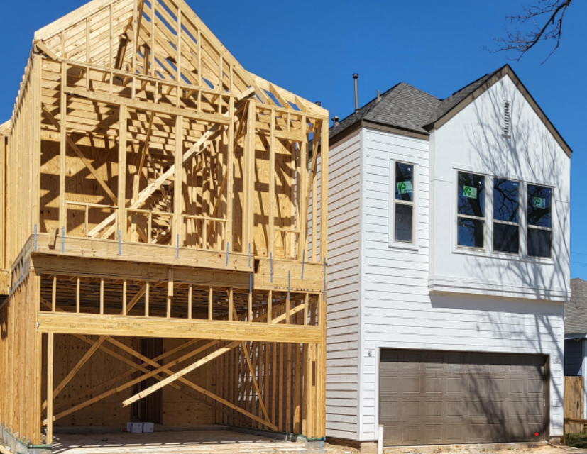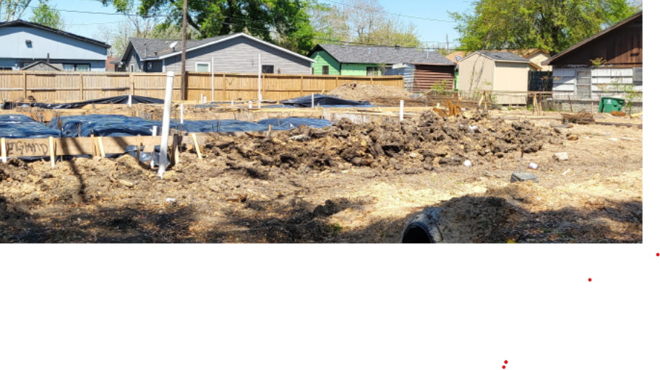

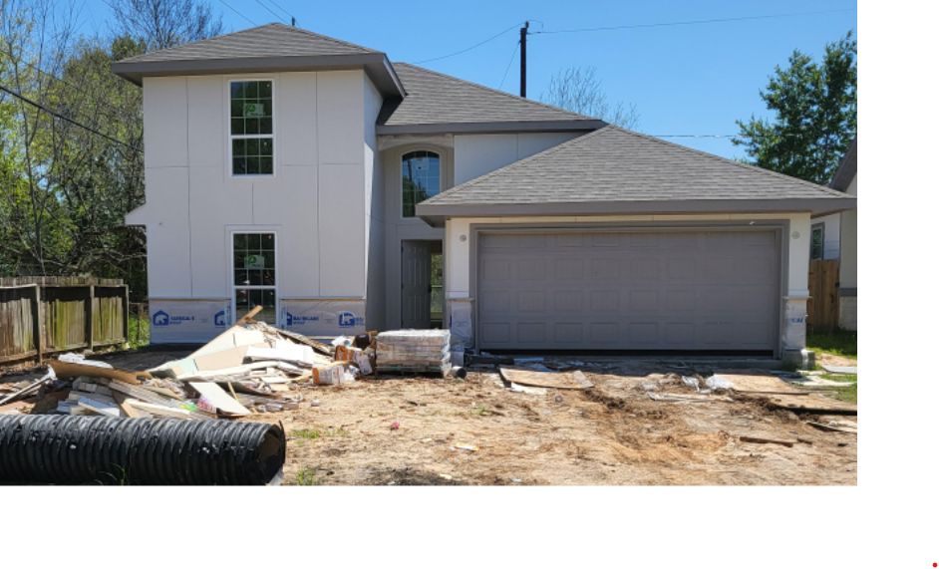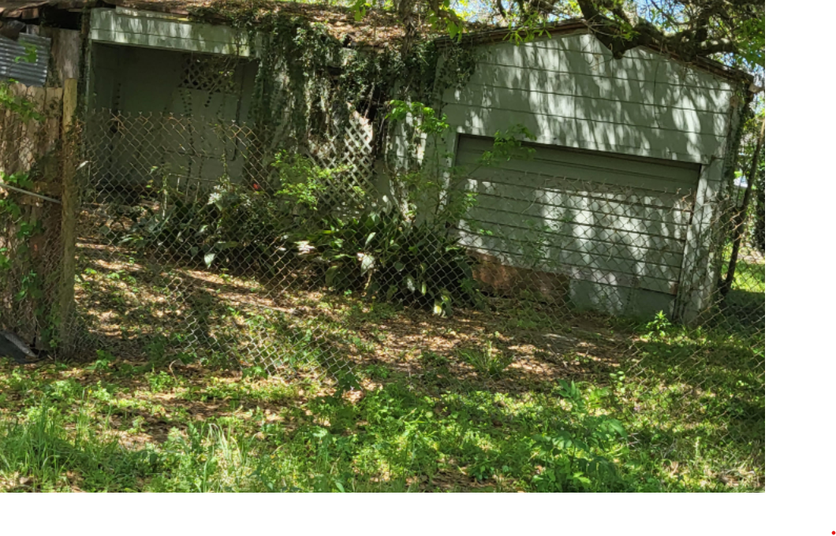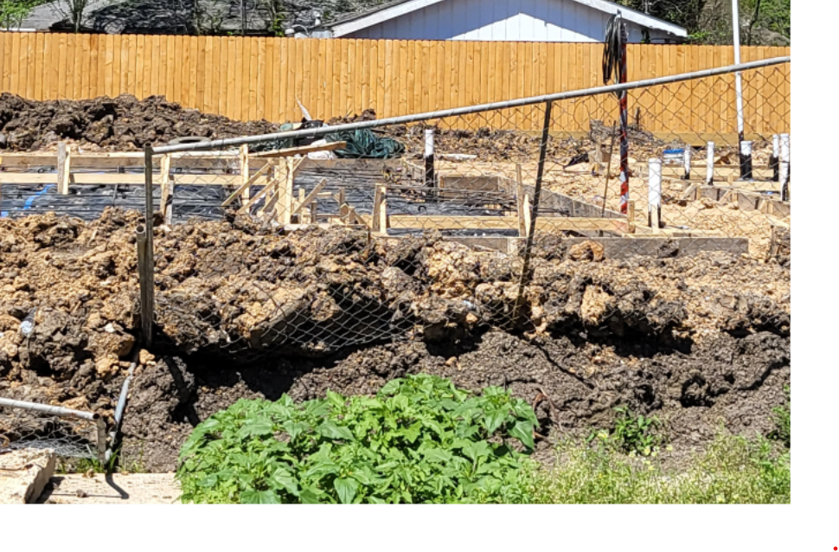

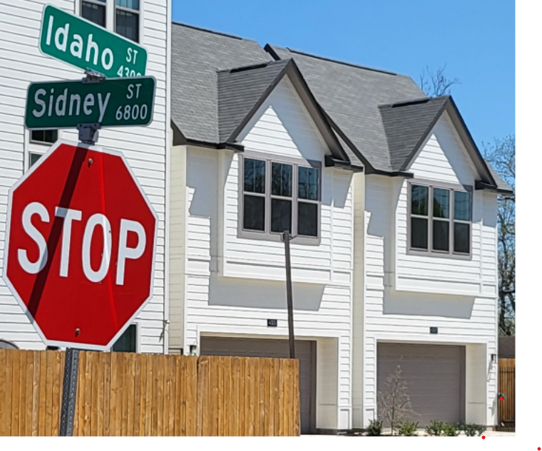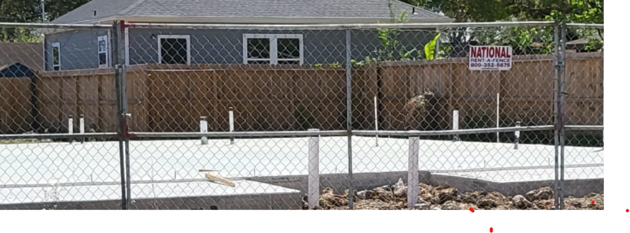

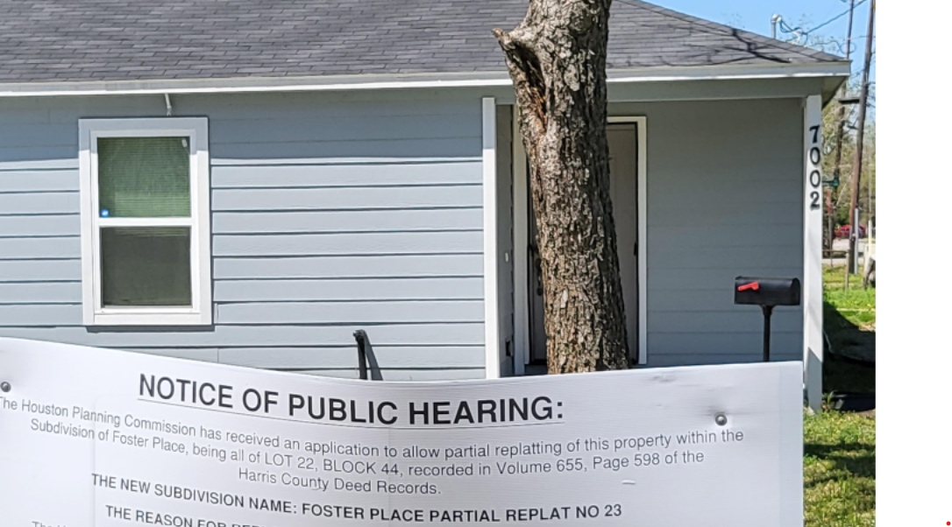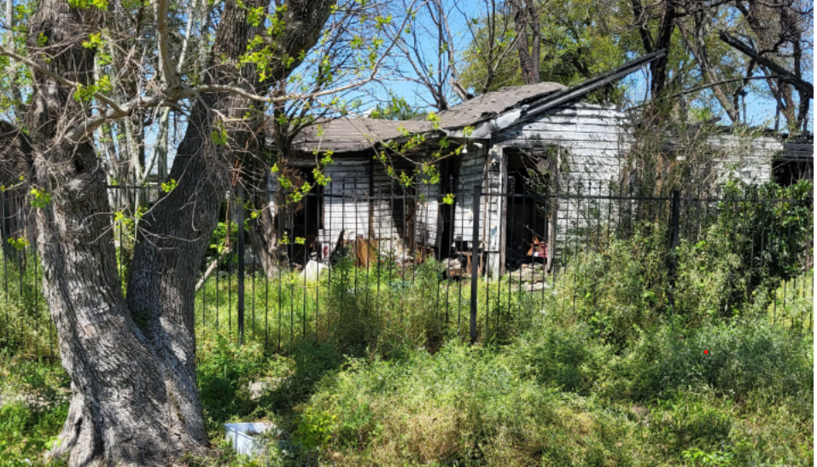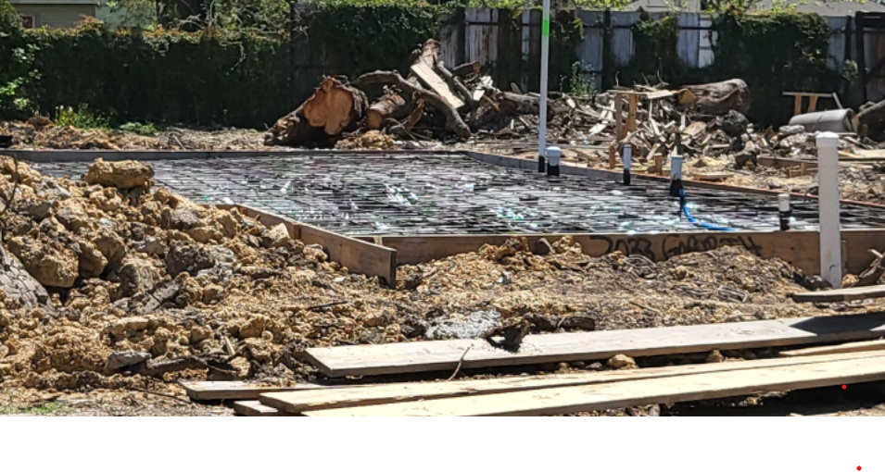

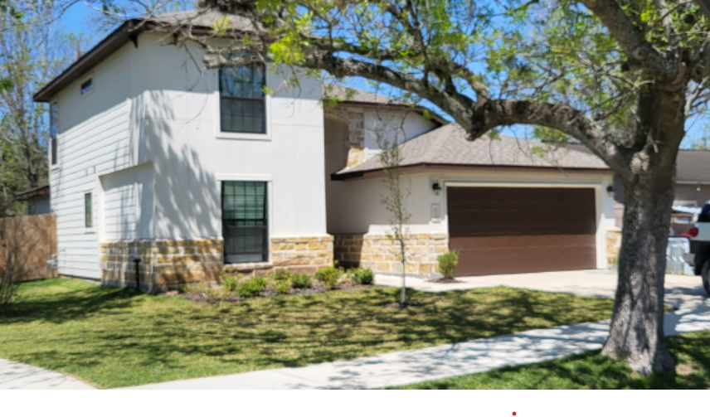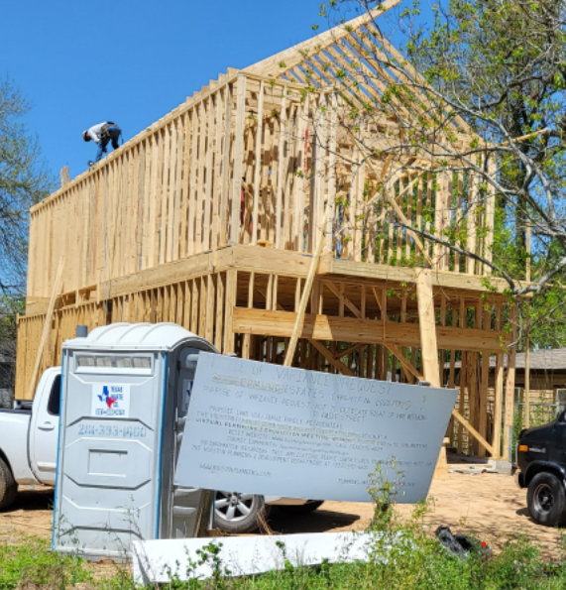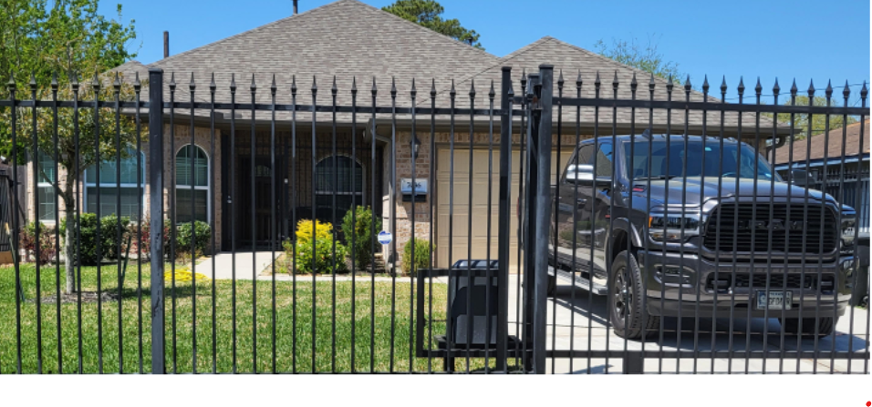

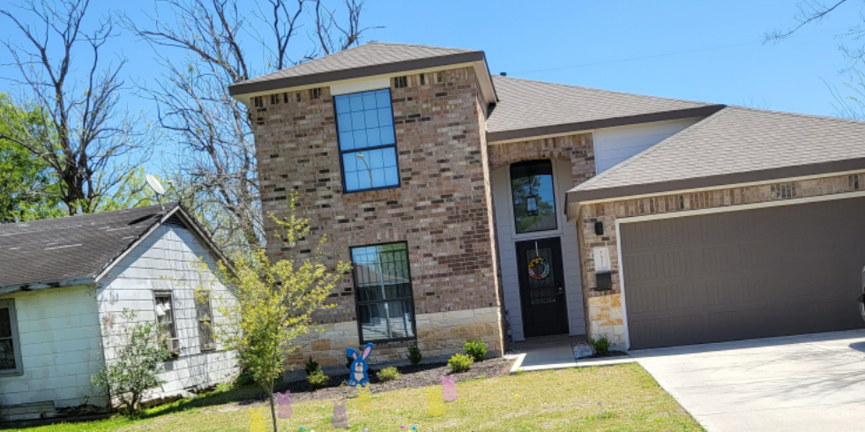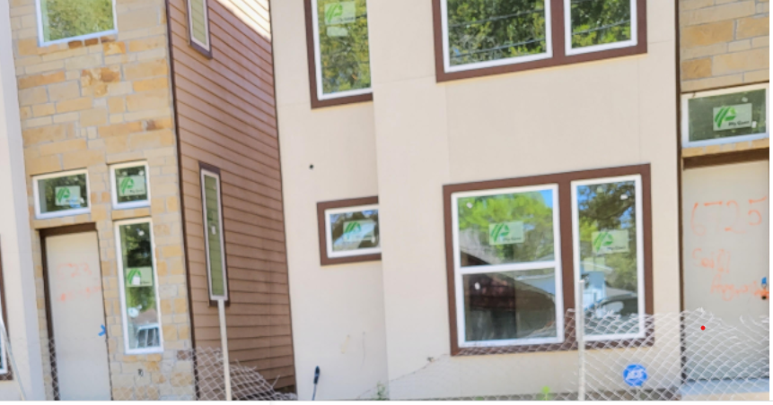

New homes/construction/vacant homes/townhomes/3-story home

Resources:

Census, CB18-41,2018, retrieved April 9, 2022

Demographics in Foster Place 1970, Census of Population & Housing - Publications - U.S. Census Publication, http//:www.census.gov, retrieved April 9, 2022

Foster Place Community, ERSI ArcGIS 2018, retrieved April 9, 2022

Foster, M.E., President of Texas Avenue Realty, Company, Julia Ideson, Houston Public Library,, retrieved April 9, 2022

Foster Place, Information File, Houston Public Library, retrieved April 9, 2022

Foster Place, www.neighborhoodscout.com, retrieved April 9, 2022

Harris County Appraisal District 2017-2021, retrieved May 4, 2022

Houston Chronicle 1942, retrieved April 9, 2022

U S Boundary, http://www.usboundary.com/Areas/Census%20Tract/Texas/HarrisData 2016, retrieved April 9, 20228

