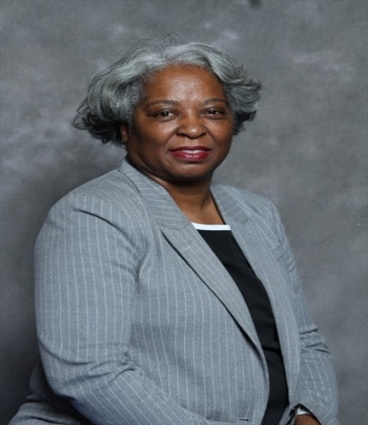
Andret Rayford
9404 Shore Juniper Houston, TX 77075
Telephone: 832-453-8586
E-Mail: andret.rayford@att.net

Objective

Passionate and creative researcher seeking a position within the urban development community, where my experience in teaching business/marketing, community development and engagement could be put into practice at the research or planning level.

Summary of Qualifications
- Enthusiastic self-starter with a thorough knowledge of organization and planning methods, insight on market analysis, research, and technology skills
- Skilled in delivering lectures and providing problem-solving guidance and study resources.
- Excellent creativity and constructive ability to motivate others, utilizing effective practice, principles, and techniques with strong organizational skills.
- Strong experience in details, database management and assessments, with demonstrated readiness ability to incorporate new/modified processes and procedures.
- Technically proficient computer knowledge in Microsoft Office (i.e., Word, PowerPoint, Excel, Outlook, Google Docs, Internet Explorer) and technology platform resources.
- Highly passionate, results-oriented, with excellent communication skills and high standards of personal and professional ethics.
Education Degrees
2019 MUPEP, Urban Planning & Environmental Policy, TxSU, Houston, TX
2016 M.Ed., Educational Administration, Texas Southern University, Houston, TX
2012 B.S., Business Administration/Marketing, University of Phoenix, Houston, TX
1998 A.A., Art Institute of Houston, Houston, TX

Work Experience
2019-Present Link Houston, Non-Profit Transportation Organization, Houston, Tx,
Community Engagement Specialist
- Community events to advocate for transportation with Zoom, Microsoft Team or Skype
- Experience different transit modes for traveling to events, workshops, or meetings
- Plan and setup materials for distribution to community residents at the events

2017 - 2019 Urban Research and Resource Center, Texas Southern University,
Houston, TX, Education Assessment and Evaluation
- Analyzing and deliver resource on identifying the academic gap
- Redefining skills and knowledge needed for urban campuses
- Research data to create resources on academic and educational reform
- Responsible for the Education Assessment and Evaluation report

Professional Experience
2013–2018 Humble Independent School District, Humble, TX
Marketing Instructor, Career and Technology Education
- Prepare and deliver lessons for career technology marketing courses, including Marketing Dynamics, Sports and Entertainment Marketing, Fashion Marketing, Hospitality and Tourism and the Work-Based Learning Program.

- Develop short- and long-term instructional objectives.

1997–2011 JC Penney, Visual Merchandiser Manager, Sugar Land, TX
- Responsible for event planning and creation of attractive visual store displays to enhance store environment and increase sales.
- Designed varied window and special promotion displays to ensure that event themes consistently fit company’s product lines, image, and targeted markets.
- Monitored design costs to work within designated budgets.
Volunteer Service
2016 Secretary Student Planning Organization, Texas Southern Univ, Houston, TX
2017 Internship Facilities, Construction and Operation, Humble ISD, Humble TX
2017 President Student Planning Organization, Texas Southern Univ, Houston, TX
2019 Huston-Tillotson HBCU Campus Summit, Austin, TX
2019 Jason Hyman REALINC LLC, Washington Terrace NH, Houston, TX
2019 Dr. Rosalyn Francis, Settegast Heights RC, Houston, TX\
2020 Third Ward Community Development Corp, Third Ward, Houston, TX

ACCOMPLISHMENTS
2017 John Clary Scholarship, APATX17 Frisco, Texas Conference
2018 Dwight D. Eisenhower Transportation Fellowship
2018 Hitchcock Legacy Project, APATX18 Galveston, Texas Conference
2019 White House Fellows National Candidate
2019 Waco Legacy Project, APATX19 Waco, Texas, Judges/People’s Choice

Webpage: andretrayford.weebly.com @AndretRayford.twitter.com
facebook.com/andret.rayford andret.rayford/Linkedin

